AnaJet® SPRINT ™
Digital Apparel Printer

User Manual

Ver 1.1 – May 2014

AnaJet LLC

AnaJet® SPRINT™
Digital Apparel Printer

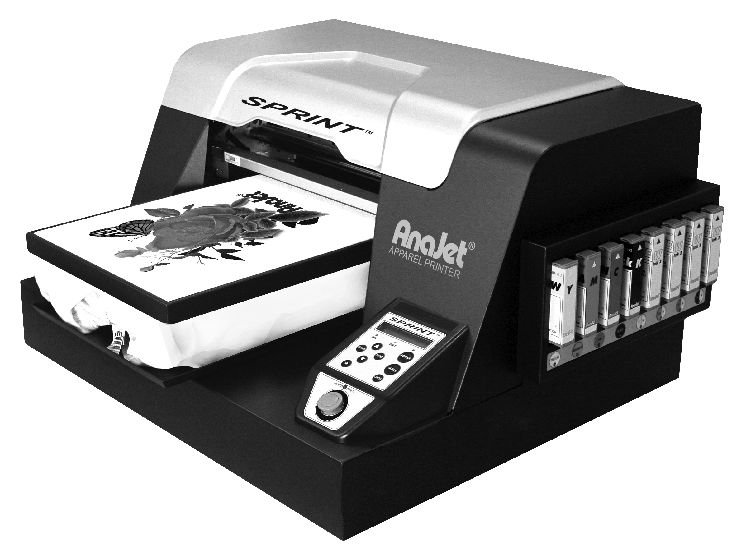

User Manual

Ver 1.1

Please read this manual before installation or use of the printer.
Keep this manual within easy reach for quick reference.

AnaJet LLC

Copyright © 2014 AnaJet Inc. All rights reserved.
Reproduction in any form is prohibited.

AnaJet and AnaBright are registered trademarks of AnaJet LLC
SPRINT and PolyBright are trademarks of AnaJet LLC

Warranty Registration

Thank you for your purchase of an AnaJet SPRINT Digital Apparel Printer. To receive technical support and access the support website, please register right away. You also need to register for the RIP program if you purchased the dark garment printing option.

Table of Contents

Table of Contents ............................................................................................ i - iii
Customer Training Check List ...................................................................... iv

Chapter 1 Start Up of a New Printer .......................................................... 1

1. Unpacking ................................................................................................... 1
2. What’s in the Box ....................................................................................... 1
3. What Else to Prepare .................................................................................. 2
4. Setting up the Printer ................................................................................. 2
5. Cabling and Power Up ................................................................................ 4
6. Installing Ink Cartridges ............................................................................. 5
7. Installing Printer Software Programs ......................................................... 6
8. Ink Charge Using Ink Pump........................................................................ 8
9. Warranty Registration ................................................................................ 10

Chapter 2 Product Information ….………………………………………. 11

1. Printer Specifications ................................................................................... 11
2. System Requirements .................................................................................. 13
3. Computer Interface Requirements ............................................................... 14
4. Consumables ................................................................................................ 14

Chapter 3 Controls ………………………………………………............... 17

1. Power Switches ............................................................................................ 17
2. Control Panel ............................................................................................... 17
3. Keys ……..………………………………………………………………... 18
4. LED Lights ……………………………………………………………….. 19
5. LCD Display …….………………………………………………………... 20
6. Error Codes ……..………………………………………………………… 22
7. Star Menu ……………………………………..…………………………... 23
8. Ink Cartridge Status LEDs ………………………………………………... 25

Chapter 4 Printer Operation ...………………………………………….... 27

1. Basic Printing Procedure ..………………………………………………... 27
2. First Time Start Up Sequence …..……………………………………….... 27
3. Power Up Sequence …….……………………………………………….... 28
4. Power Down Sequence ….………………………………………………... 29
5. Moving Print Table ……...……………………………………………..…. 30

6. Adjustment of Print Table .……………………………………………...... 31
7. Printing Operation ………………………………………………………... 34
8. Canceling a Print Job …….…………………………………………….…. 37
9. Obstruction Sensor ………...…………………………………………..….. 37
10. Auto System Maintenance ………………………………………….……. 38

Chapter 5 Printer Software …………………………………..……...……. 41

1. Built-in Raster Image Processor …..………………………………...…….. 41
2. Accessing the Printer Program and Page Setup …..……………………….. 41
3. Using the SPRINT Printer Driver …………………………………...…….. 44
4. Ink Test Pattern ……………………………………………………...…….. 47
5. Using SPRINT Printer Utilities ……………………………………..…….. 49
6. Print Nozzle Purge by Print Head ………………………………...……….. 52

Chapter 6 Printing on Black Garments ….……………………………..... 55

1. Basic Black Garment Printing Process …...……………………………...... 55
2. Maintenance of Printers with White Ink …..…………………………...….. 55
3. Scheduled Maintenance for Printers with White Ink Installed ………...….. 56
4. In Case You Cannot Perform Regular Maintenance …………………......... 58
5. Handling of Unused White Ink Cartridges ...…………………………….... 58
6. Pre-treatment of Dark Colored Garments ….…………………………..….. 59
7. Printing Dark Garments ………………………………………………..….. 60
** White Ink Level Setting** ……….…………………………………..….. 61
8. Dark Garment Washing ……..………………………………………..……. 62

Chapter 7 Maintenance and Transportation ……………………..……... 63

1. Basic Maintenance Utility ...……………………………………..……….. 63
2. Replacing Ink Cartridges ….……………………………………..……….. 63
3. Switching from One Type of Ink to Another ...………………..………….. 66
4. Cleaning Maintenance Station and Nozzle Plate …..……….…………….. 67
5. Waste Ink Tank and Ink Drip Foam ………..…………….……………..... 70
6. AnaJet SPRINT Utility Program.……………………….…………………. 72
7. Service Count Reset ..................................................................................... 75
8. Cleaning the Printer ..................................................................................... 77
9. Transporting the Printer ............................................................................... 77

Chapter 8 Troubleshooting …………………………………….…............. 83

1. The Print Engine Does Not Turn On …………………………………….... 81
2. The Printer Does Not Print Anything ……………………………………... 82
3. Prints Are Not What You Expected ..............……………………………… 83
4. The Print Quality Is Not Good …………………………………………….. 86
5. Color Image is Printing in Black Only ……………………………….......... 89
6. Printing is too Slow ………………………………………………...........…. 89
7. As Soon As the PRINT Button is Pressed, the Obstruction Sensor is Triggered 90
8. Print Table Does Not Travel All the Way to the Front or Rear ..………….. 90
9. Broken LCD Display Characters or Garbled Characters ........…………….. 90
10. The Print Head Nozzles Gets Clogged Too Often ..…..………………….. 91
11. Obstruction Sensor Laser Adjustment ……………………………............ 92
12. Communication and USB Related Problems ..........……………...………. 93
13. Cable Problems .......…………………………………………..………….. 95
14. How to Get Additional Help .......…………………………..…………….. 95

Appendix

1. AnaJet SPRINT Consumables Recommended Stock Level ……………… 97
AnaJet SPRINT Non-consumables List ..…………………………………. 97

2. WHITE INK SYSTEM MAINTENANCE CHECK LIST .…………...…. 99

3. Updating Printer Firmware ……………………………………………....... 101

4. EKPrint Studio for AnaJet SPRINT Manual …….…………....................... 107

5. AnaJet Limited Warranty …………………………………………………... 133

Congratulations on your purchase of an AnaJet SPRINT Printer! You should attend the AnaJet University full training program at the earliest possible time to get the most out of the system. If you are outside the USA, your distributor is responsible for providing you the proper training on the use and maintenance of the printer. At minimum, the following topics should be covered during the training. Check them off as the training progresses.
Customer Training Checklist

__ 1) Today’s direct to garment printers need regular maintenance and good care for acceptable ink flow when used with white ink.

__ 2) Leveling the Printer and proper Printer Placement for good print quality.

__ 3) Print Table Height Adjustment / Using the Gauge Block properly.

__ 4) Print Head Alignment.

__ 5) Loading Garments on the Print Table and Placement of Garment on Print Table in relation to the Graphics program / Print Preview.

__ 6) Obstruction (laser) Sensor.

__ 7) Ink Level Test Pattern and Proper Specification of Ink Level.

__ 8) Print Head Cleaning, Nozzle Check, Print Nozzle Purge, etc. (What to do when ink flow is not good? Excessive Head Cleaning causes air foam, etc.)

__ 9) The need for Regular Printer Maintenance and Cleaning.

__ 10) Accessing Maintenance Station / Moving the Carriage off the Maintenance Station.

__ 11) Cleaning Maintenance Station, Nozzle Plate Edges, etc.

__ 12) Printer Environment, Humidity and Temperature.

__ 13) Reset Service Counter.

__ 14) Waste Ink Drain operation.

__ 15) Control Panel Functions, Navigation and Star Menu.

__ 16) Proper Black Shirt Pre-treatment.

__ 17) Printing white shirts / printing black shirts.

__ 18) Proper use of RIP program for black shirt printing.

__ 19) Getting proper color for white and black shirts.

__ 20) Installing ink cartridges, low ink warnings, replacing ink cartridges.

__ 21) Ink Charge, Service Count Reset and Proper Use of SPRINT Utility Program.

__22) How to ship the printer. Charge cleaning solution, use original shipping box and pallet.

Chapter 1 Start Up of a New Printer

1. Unpacking

The printer box should always be placed right side up as indicated by the arrows. Open the top flap and take the printer out of the box with the help of a second person. Do not attempt to handle it alone as it can damage the printer. Keep the printer top side up while removing it from the shipping box and foam.

When the printer is placed on a flat surface, remove the packing material. Make certain that you retain all of the packing materials, including the Table Retainer cardboard. The printer cannot be properly protected without the provided packing materials if it needs to be shipped for any reason, including warranty repair.

2. What’s in the Box

- AnaJet SP-200 SPRINT™ Printer
- Power cord
- USB cable
- User Manual
- AnaPrint SPRINT Driver Program CD
- 1 sets of CMYK bulk ink cartridges (a total of 4 cartridges)
- 8 cartridges of AnaBright® Cleaning Solution
- Gauge Block
- Cleaning Fluid (2 oz. bottle) (for Maintenance Station, Wiper Blade, etc.)
- Cleaning Applicators (1 pack)
- 1 box of AnaJet SoftTouch Heat Press Paper

If you acquired a printer with the Dark Garment Printing Option, AnaJet P/N SP-200PPA or SP-200PPB, you will also get the following items:

- EKprint Studio for AnaJet SPRINT RIP Program CD
- 4 cartridges of AnaBright® White Ink
- 1 bottle of AnaBright® White Ink Pretreatment Liquid (64 oz.)

All items other than the printer are packaged in a long Accessory Box inside the printer box. Keep all accessory items handy for future use.

3. What Else to Prepare

The following items will also be needed for your AnaJet printer operation:
- Sturdy, stable and level table to place the printer on.
- 12 or 9 inch level (commonly called “torpedo level”) for installation of the printer.
- Electronic hygrometer/thermometer (to monitor the relative humidity of the room printer is operating in).
- PC computer with Windows XP or Windows Vista 32bit operating system.
- Graphics software installed in the PC, such as Photoshop, CorelDraw, Photoshop Elements or Illustrator.
- Heat press or textile oven (for heat curing of the ink).
- Optional: Silicon treated parchment paper or Teflon pad for heat curing.
- Adequate supply of garments to print.
- Paper towels.
- Standard 8 1/5 x 11” or 11x17” copying or printing paper.

If you are printing on dark colored garments with white ink, you also need the following items. The EKprint Studio Program (RIP software), White ink, and Pretreatment Liquid are provided if you bought the SPRINT with Dark Garment Printing Option. See Chapter 6: Printing on Black Garments for details.

- EKprint Studio Program for dark shirt printing installed on the PC.
- Pretreatment Station or Pre-treatment Booth and Electric Sprayer or pump type sprayer for pre-treating dark garments.
- AnaBright® white ink cartridges.
- AnaBright® Pre-treatment Liquid.

If you are printing on high performance fabric of polyester, nylon, rayon or spandex type:

- PolyBright™ Ink: a set of CMYK ink cartridges
- PolyBright™ Primer if printing on Nylon or Rayon (Recommended)

4. Setting up the Printer

A. It is very important that the printer be operated on a stable, sturdy and level table.
Ensure the table is sturdy enough so the printer does not shake or vibrate during operation. Operating the printer on an uneven or slanted surface will cause poor print quality and can damage the printer.

B. Open the printer’s top cover. Remove the blue tapes that are attached to the Print Head Carriage for shipping.

Remove the Table Retainer cardboard material (see Figure 1.1). You must keep the Table Retainer for future use for printer shipment. Now you can move the Print Table manually back and forth to make certain that the Print Table is free. Generally observe all internal mechanisms to make sure that nothing has gone wrong during shipping.

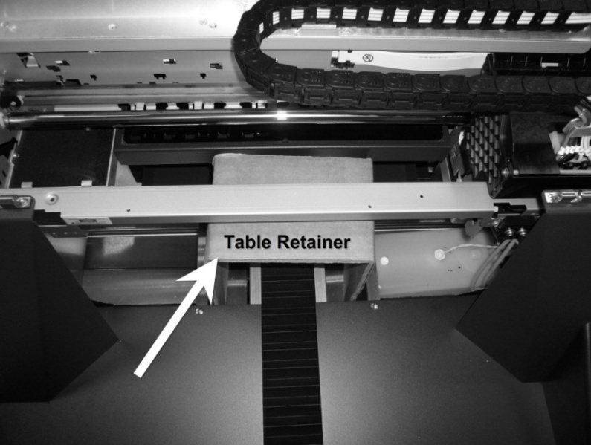

Figure 1.1: Table Retainer

C. Next it is necessary to make certain that the printer itself is level. Push the Print Table all the way back by hand. Place a 9” or 12” “torpedo level” at the near side (closest to you) of the exposed rails (see Figure 1.2). Adjust the feet as necessary to make the two parallel rails level. Then pull the Print Table all the way to the front. Place the torpedo level behind the Print Table on the far side of the rails (See Figure 1.3), and adjust the feet as needed. If not properly adjusted, the printer will not operate properly or the print quality will suffer. Upon completing inspection, close the printer cover.

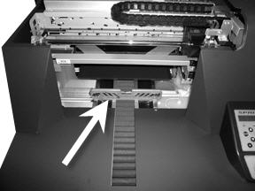

Figure 1.2: Leveling the Near Side of the Printer
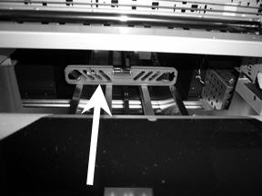

Figure 1.3: Leveling the Far Side of the Printer

5. Cabling and Power Up

A. Plug in the provided power cord to a wall outlet. AnaJet SPRINT printers come in two power configurations. Model SP-200A is for 110V for USA, Canada, Mexico, Japan and other countries using 110/117V standards. Model SP-200B is for 220 or 240V for UK, Europe and most other countries using 220/240V standards. Model SP-200B can also be configured for 110V by changing the switch tab settings in the power entry module. Make certain your printer’s power setting matches with the voltage of your power outlet. (See Figure 1.4)

Next, plug the power cord into the power entry module in the rear of the printer. At this point, do not plug the USB Cable into the printer or PC.

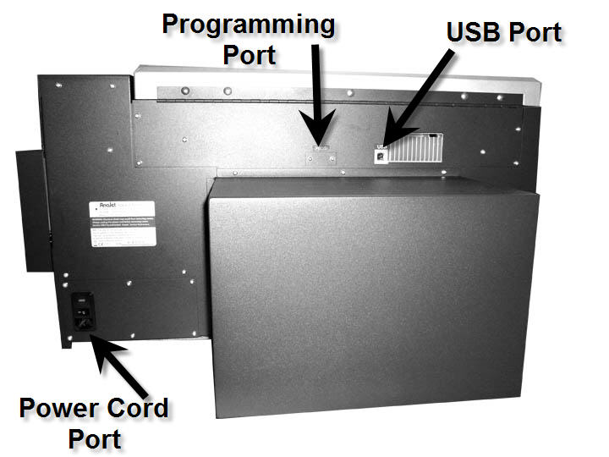

Figure 1.4: Plug in the Power Cord
- Turn on the power switch on the rear of the printer. The printer control panel LCD display will light up, and shows the following display.

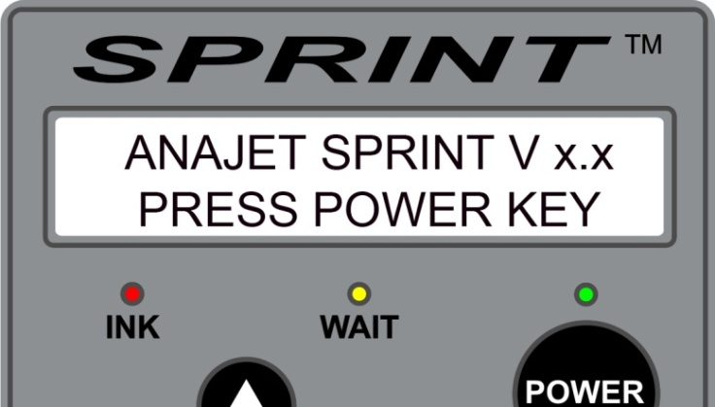

Figure 1.5: Printer Control Panel Display

Since the ink cartridges are not installed yet, all the LEDs under the cartridge bays will turn on.

6. Installing Ink Cartridges

Before turning on the print engine, it is necessary to install the ink cartridges. If you are planning to print on cotton and cotton blends, install AnaBright® ink cartridges. The ink cartridge bay is located on the right-hand side of the printer.

A new printer is shipped with 8 AnaBright® ink cartridges: 2 sets of each color: yellow, magenta, cyan and black. Remove the cartridges from the container and gently shake a few times before installing them into the ink bays.

Note: After you have been fully trained on the printer, you can install four white ink cartridges in cartridge bays 5 through 8. The use of white ink is strongly discouraged without full training at AnaJet University or by your dealer, unless this is your second or third AnaJet printer. White ink tends to settle and clog the ink system and print head if proper regular maintenance is not performed. It also requires a higher level of operational knowledge. AnaJet strongly recommends that you operate the system with two sets of colored inks for the first two or three months until you become proficient with the system and maintenance. See detail in Chapter 6: Printing on Black Garments.

The ink bays are not keyed by ink color, so it is very important that the correct color ink cartridge gets installed in the correct bay as shown below in Figure 1.6.

 | Bay 1 | Bay 2 | Bay 3 | Bay 4 | Bay 5 | Bay 6 | Bay 7 | Bay 8
For Light  Garments Only | Yellow | Magenta | Cyan | Black | Yellow | Magenta | Cyan | Black
For Light and Dark Garments | Yellow | Magenta | Cyan | Black | White | White | White | White

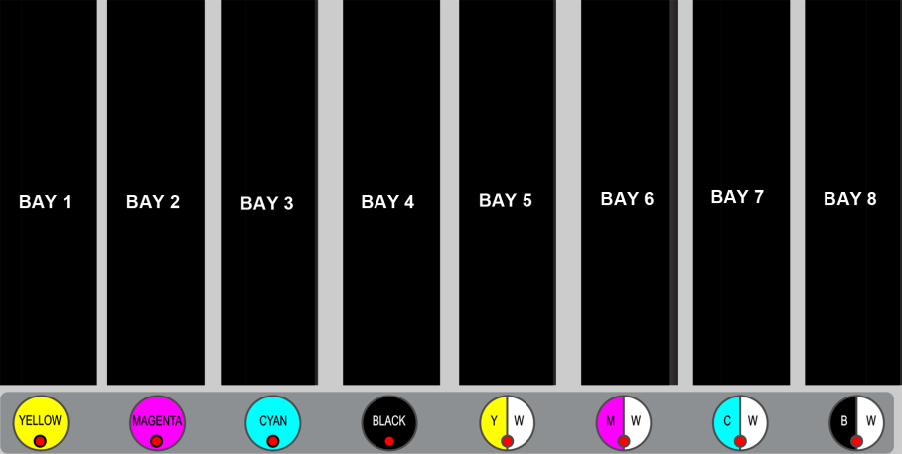

Figure 1.6: Ink Cartridge Bay Configuration

Once you insert an ink cartridge, the red LED light below the cartridge bay should turn off indicating the cartridge is installed properly. A continued red LED light indicates that the cartridge is not installed properly. Pull the cartridge out and reinsert it carefully. Unless all cartridges are installed, the printer will not print. If a cartridge is pulled out during a print, the printer will draw air into the ink tube blocking ink flow.

If you install a cartridge in the wrong bay, it can contaminate the ink delivery system. Depending on how far ink has traveled in the ink delivery system, you may need to use a Cleaning Solution cartridge to flush out the wrong color ink from the system to avoid ink contamination. You can observe how far it filled the ink delivery system by looking at the ink tubes, which can be partially seen by opening the printer cover.

7. Installing Printer Software Programs

Once the ink cartridges are installed, it’s time to install the AnaPrint SPRINT printer driver program onto the PC. It requires a fair amount of knowledge of PC operation and Windows operating system to install and operate the AnaPrint program. If you are not familiar with these, it is recommended that you seek help from someone who is familiar with such technology to set your computer up and make sure that your computer and the AnaJet printer are communicating properly.

(1) First, power up the SPRINT printer’s print engine by pressing the POWER key on the control panel.

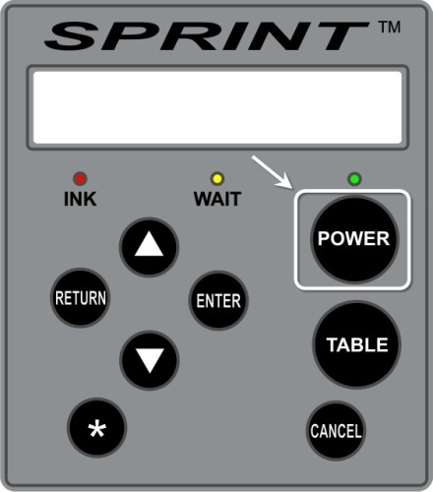

Figure 1.7: Powering Up the Print Engine

It will take about two minutes for the print engine to complete the power up sequence. The Print Table will move forward to the Loading Position. When the power up sequence is completed properly, the following display will show on the LCD.

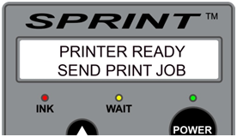

Figure 1.8: LCD Display When the Print Engine is Powered On

You can move the Print Table by pressing the TABLE key in the control panel. Pressing it again will bring the Print Table back to loading position.

(2) Your PC must have Microsoft Windows XP or Windows Vista 32bit edition operating system, and the PC’s USB port must support USB 2.0.

- Insert the provided CD with the AnaPrint SPRINT driver program in your PC.

- Plug in the provided USB Cable to the USB port in the rear of the printer and your PC USB port. (Your printer print engine must be turned on.) Windows will prompt that a new hardware is found and will instruct you about how to proceed to install a new printer driver. Follow the on screen instructions to install the SPRINT driver program. Make certain that you select the correct driver language from within the AnaPrint CD. Windows will automatically find the USB port and set the program for proper communication. It is very important to follow the on screen Windows instructions properly.

- During the installation process, make sure that AnaJet SPRINT is chosen as your default printer. If you miss the opportunity to do so, refer to Chapter 8: Troubleshooting, Section 12: Communication and USB Related Problems from this manual to set it as the default printer.

- During the AnaPrint program installation you will want to note the USB port that Windows is assigning to the SPRINT printer. It will be a good idea to write down the assigned USB port (like USB 1 or USB 3, etc.) in this manual so that you can refer to it later if you need to.

(3) If there are any problems in communication between the computer and printer, refer to Chapter 8: Troubleshooting, Section 12: Communication and USB Related Problems and Section 13: Cable Problems.

(4) If you purchased an optional EKprint Studio (RIP program for black garment printing), you can also install the program at this time. However, we recommend you skip this process at this time and install it later after you have had a chance to get familiar with white shirt printing using the AnaPrint program. You can always install the EKprint Studio program later by following the instructions included with the program.

8. Ink Charge Using Ink Pump

Your printer was shipped with the ink delivery system filled with Cleaning Solution (clear or pink in color) to preserve the integrity of the ink delivery system and prevent the print heads from drying out. The Cleaning Solution has to be replaced with the printing inks prior to printing. Follow the instructions below to fill the system with printing ink.

- Open the printer’s cover so that you can observe the ink tubes running from the ink cartridge bays to the print head damper. The ink tubes are transparent so that you can partially observe as the inks fill the tubes.

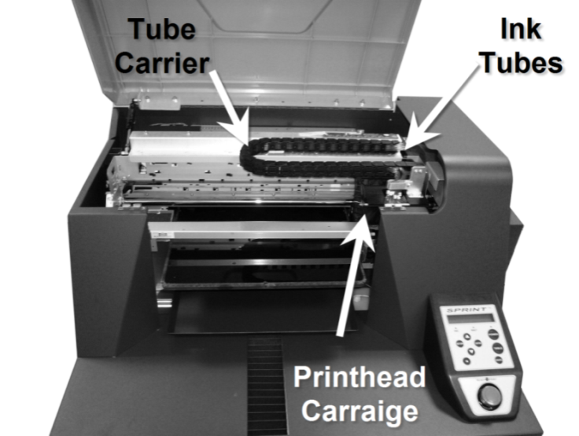
Figure 1.9: Observe Ink Tubes During the Ink Charge

- If the Control Panel Power LED is on, press the POWER key to power down the Print Engine. [Note that you will need to leave the Main Power Switch on.] The Ink Pump function will not activate while the Print Engine is on.
- Press the STAR (*) key and then press the DOWN button repeatedly until “INK MAINTENANCE INSTRUCTIONS” is displayed.
- Press the ENTER button; the following screen will be displayed:

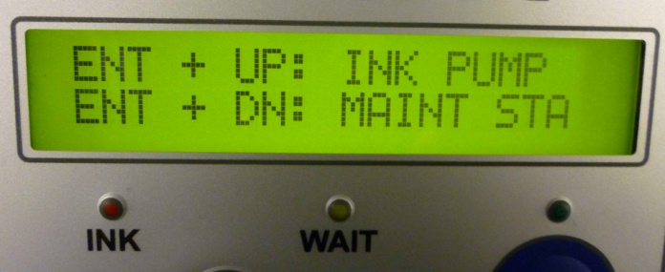

Figure 1.10 Control Panel Display of Ink Maintenance Instructions

- Make sure that the Print Head is as far to the right as it can go. If the Maintenance Station is slightly to the left, it may not make an effective seal for the purpose of charging ink.
- Press and hold the ENTER and UP keys simultaneously.
- The printer will start pumping ink and the Cleaning Solution will start moving along the ink tubes into the Waste Ink Tank. You will observe the ink gradually replacing the Cleaning Solution in the tubes.
- Make certain that the inks have reached all the way through the Dampers in the Print Head Carriage for each of the eight ink tubes.
- The Ink Charge operation is completed when all the tubes from the Maintenance Station to the Waste Ink Tank are completely filled with inks.
- When all of the ink tubes are filled with printing inks, power on the Print Engine with the Power key on the Control Panel. During the power on process, if the printer does not do an Automatic Head Clean, manually perform a Head Clean.
- After the Head Clean, perform a Nozzle Check to see if the inks have filled the Print Head. Make sure you read Chapter 5: Printer Software, Section 5: Using SPRINT Printer Utilities before attempting a Head Clean or Nozzle Check.

9. Warranty Registration

Be sure to complete Warranty Registration at the AnaJet website. Go to www.anajet.com and click Registration. You will receive a registration confirmation by email. If you have more than one AnaJet printer, do not register as a new customer. Simply log into your account and add additional printer models and serial numbers.

When you complete Warranty Registration, you can also sign up for AnaJet User Forum on the same website. The Forum is a community of AnaJet Users and provides a wealth of information for all users for both operational efficiency and business ideas.

Before proceeding to Printer Operations, get familiarized with the Printer Controls in Chapter 3.

Chapter 2 Product Information

Figure 2.1: AnaJet SP-200 System

1. Printer Specifications

Printing Method: Direct to Garment Inkjet printing

Print Head Technology: Print on demand piezo-electric inkjet

Printing Resolution: 720 x 720 dpi (Normal Mode)
1,440 x 720 dpi (Fine Mode)
1,440 x 1,440 dpi (Super Fine Mode, accessible by RIP program.)

Number of Ink Channels: 8

Printable area: 12.5” x 16.0” (31.72cm x 40.64cm) Print Table
Mechanical:
Garment loading method: Print Table, Hooped and Non-Hooped Operations
Garment Path: : Shuttling Print Table
Ink Supply : Sealed Ink Cartridges
Printer Dimensions : 29.8” x 33.7” x 14.9” (76cm x 86cm x 38cm)
Table Height Adjustment: Up to .8” (2.03cm)
Weight : Approx 82 lbs (37Kg)

Electrical:

 | 110 V Model (SP-200A) | 220V Model (SP-200B)
Input Voltage Range  Input Frequency Range  Power Consumption | 110 – 132 V  50 – 60 Hz  1.0 A (maximum)  .15 A (idling) | 212 – 245 V  50 – 60 Hz  .5 A (maximum)  .08 A (idling)

Environmental:

Temperature (printer): Operation: 61°F to 90 °F (16°C to 30°C)
Storage (without ink carts): 14° F to 104° F (-10°C to 40°F)

Temperature (inks): 41°F to 90°F (5°C to 32°C)

Humidity (printer): Operation: 45 to 80% RH, non-condensing.
Storage: 20 to 85% RH, non-condensing.

It is especially important to meet the Relative Humidity (RH) requirement for good ink flow. If the environment is dry and below the specified RH, the ink will dry out at the Print Head causing nozzles to clog. Keep an electronic hygrometer close to the printer, preferably on the Garment Tray below the Print Table. Use a high powered humidifier if necessary to increase the humidity in the immediate area of the printer. If you experience more than normal Print Head Nozzle clogging, it is preferable to provide above 50% RH. Inexpensive electronic hygrometers are available in electronic stores, department stores or hardware stores, but they may be inaccurate. Most electronic hygrometers are accurate at mid to high humidity range, but show inaccuracy below 40% RH. It will be necessary to have them calibrated regularly.

Figure 2.2: Electronic Hygrometer (Needs Regular Calibration)

Relative Humidity below 40% is a warning for upcoming print head clogging. Preferably keep the RH above 50%.

2. System Requirements

AnaJet printers are designed to be used with a PC running Windows XP, Windows Vista or Windows 7 Operating System. The programs needed to run your SPRINT printer do not work with an Apple computer unless it is running Parallels, Bootcamp or other software that allows one to run Windows on Apple computers. A PC with an operating system other than Windows XP, Windows Vista or Windows 7 will not work. . There are no specific hardware requirements to run the AnaPrint SPRINT program. However, to run the optional EKprint Studio program for black garment printing and typical graphics programs used for apparel decoration applications such as Photoshop and CorelDraw, the following hardware specifications are suggested. Also note that the EKprint Studio for SPRINT program is required to for AnaJet software to be compatible with 64 bit systems.

Minimum System | Recommended System
Pentium 4, running at 1GHz  1 GB of RAM  10 GB of free Hard Disk space  VGA Monitor  USB 2.0 ports | Pentium 4, running at 3.0+ GHz, or  Pentium Duo Core, running at 2.0+ GHz  2+ GB of RAM  20+ GB of free Hard Disk space  1024x768 + Resolution Monitor  USB 2.0 ports

Notice that the amount of memory required varies depending on the number and kinds of application programs open. The more memory (RAM) you have, the more efficiently your programs will run. Generally speaking, the best payback of your computer investment dollar will come from more memory. In a tight budget situation, allocate more money to memory upgrade. 2+ GB is preferable for graphic printing applications.

3. Computer Interface Requirements

There are no specific interface requirements except that your computer must have USB 2.0 ports to connect to the SPRINT printer using the provided USB cable.

In the event the firmware in your printer needs updating, the firmware programming is also done through a USB port on your computer connected to your printer’s Programming Port.

4. Consumables

Printing ink and Cleaning Solution are the primary consumables. AnaBright® inks are general purpose printing inks for printing on cotton, cotton blends and other common natural fiber materials. AnaBright® ink comes in five colors: Yellow, Magenta, Cyan, Black and White. AnaJet PolyBright™ inks are for printing on polyester, rayon, spandex, nylon and other synthetic fiber materials. AnaBright® and PolyBright™ inks have very different chemical properties, and they should never be mixed or used together. AnaBright® Cleaning Solution can be used for cleaning both AnaBright® and PolyBright™ inks. PolyBright™ comes in four colors: Yellow, Magenta, Cyan and Black.

For printing on dark colored garments with AnaBright® White Ink, it is necessary to pre-treat the printing area with AnaBright® Pre-treatment Liquid. For printing on nylon and rayon, it is recommended to pre-treat the printing area with PolyBright™ Primer for best results.

This User Manual provides general guidelines for using AnaBright® and PolyBright™ inks. But there is a great deal of variation on the way digital inks interact with a specific textile material. The ink performance can vary significantly depending on the exact chemical characteristics of the textile and the way the fabric is woven or knitted. It is not uncommon for garment manufacturers to treat the fabric with special chemicals for various reasons. Thus, the performance of AnaJet inks on a specific fabric may vary significantly and the ink may not work at all for a given garment. AnaJet does not guarantee any of its inks will work on a specific garment. When you are printing on an unfamiliar fabric, it is always necessary to test prior to production run.

See Appendix 1 for the list of consumables. Keep a reasonable quantity of consumables handy so as not to run out of them, but do not stock up too many ink cartridges as they have expiration dates. Use all ink cartridges before the indicated expiration dates. Generally, AnaBright® and PolyBright™ CMYK inks expire in 12 months after the manufacturing dates. AnaBright® White ink expires in 6 months from the manufacturing date. Cleaning Solution, Pretreatment Liquid and PolyBright™ Primer have much longer shelf lives, typically 3 years. Expired inks tend to agglomerate and will clog the ink delivery system and Print Head, thus damaging the printer.

Chapter 3 Controls

AnaJet SPRINT printer controls consist of the main power switch, the control panel and the ink bay status indicator LED lights.

1. Power Switches

The power is controlled by two switches: The main power switch and print engine power key. The main power switch is on the rear right side. The printer comes configured either as a 110V printer (Model SP-200A) or 220V printer (Model SP-200B). Make certain that your printer power specification matches your wall AC outlet power level.

When the main power switch is turned on, it powers the printer’s mechanical and garment moving subsystem. The control panel LCD will display ANAJET SPRINT Vx.xx / PRESS POWER KEY. This indicates that the main power switch is on, but the print engine is not yet powered. Press the POWER key on the control panel; this turns on power to the print engine.

The power down sequence is the reverse. Always press the POWER key on the control panel first. The system will initiate the power down sequence, including proper parking of the maintenance station. After the print engine is completely powered down, the LCD will display POWERED OFF. Shortly, the display will change to ANAJET SPRINT / PRESS POWER KEY. You can now switch off the main power switch on the rear of the printer.

It is recommended that the printer and print engine are left on at all times, even when the printer is not used. Keeping the power on enables the printer to perform periodic minimal self maintenance routines that help prevent the print head from drying out. While the printer is not actively used, it is recommended to set the Auto Print Head Maintenance to actively manage the print head maintenance.

2. Control Panel

The AnaJet SPRINT Control Panel consists of a 20 character by 2 line LCD display, 8 keys and 3 LED indicator lights. Below the Control Panel are the PRINT button and Print Ready LED light. The control panel layout is shown below in Figure 3.1.

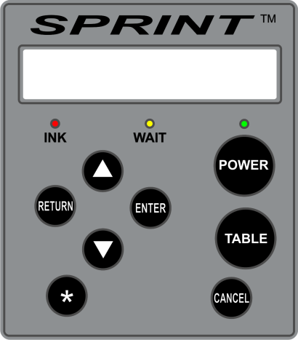

Figure 3.1: Control Panel

3. Keys

POWER key turns on the print engine power. The POWER key will not be functional unless the main power switch on the rear of the printer is already turned on. You will know the main power switch is turned on when you see a display in the LCD.
To turn off the print engine, press POWER key.
 | TABLE key moves the Print Table back and forth. Pressing it while the Print Table is moving will stop the table. Pressing it again will move the table in the opposite direction. When the Print Table reaches either the front or the rear limit, the table will stop automatically.
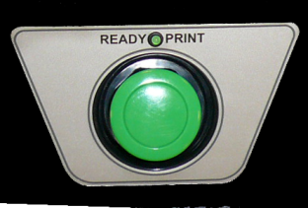 | PRINT button initiates the printing operation. Always send a print job first from the PC to the printer. When the green Print Ready LED above the Print button lights up, the printer is ready to print. Press the PRINT button, the table will start moving toward the rear to initiate printing operations.  When the Print Ready LED is not lit up, pressing the PRINT button does not perform any function.
 | Up Arrow key is used to navigate the menu displayed in the LCD display.
 | Down Arrow key is used to navigate the menu displayed in the LCD display.
RETURN key is used to navigate the menu displayed in the LCD display.
During a dark garment printing operation, pressing RETURN key while the Print Ready LED is on (instead of the PRINT key) allows for Single Touch Dark Garment Printing.
 | ENTER key is used to confirm or enter the menu item currently displayed in the LCD. Every menu operation at every step requires entering the ENTER key.
 | CANCEL key is used to cancel an operation, usually the Print operation.
 | Star key is used to call Star Menu on the LCD display. Star menu is generally printer settings, such as Obstruction sensor, Audible signal, Ink Cartridge Monitor setting, etc.

4. LED Lights

POWER (green) | ON indicates the power to the print engine is on.  OFF indicates the power to the print engine is off.  BLINKING indicates the printer is busy, either receiving data from the PC, printing, performing maintenance, etc. When the Power LED is blinking, do not press any key.
WAIT (amber) | Normally it is OFF.  ON indicates that ink system is being renewed. LCD usually explains the reason. Possibly, it can signal an error (see Chapter 8: Troubleshooting).
INK (red) | Normally it is OFF.  ON when one or more of the ink cartridges are missing or improperly installed in the ink bay. All cartridges must be installed to print.  BLINKING means one or more of the ink cartridges are out of ink or very low in ink. The printer will continue to print, but it will give an audible beep and LCD display warning each time a print is completed. When the INK LED is blinking, it is necessary to replace the cartridge as soon as the current print job is completed. Continued use of printer with an empty cartridge(s) will induce air into ink delivery system. It can also damage the printer.
PRINT READY (green) | ON when the printer receives a job and is ready to print. When the Print Ready light is on, press the PRINT button to start print operation. When a multiple copy job is sent, the Print Ready LED will go ON as soon as the next copy of print is ready to print.  Pressing the PRINT button while the Print Ready light is OFF will not invoke any activities.

5. LCD Display

The LCD display is a 20 character x 2 line Liquid Crystal Display (LCD). It is back-lit for easy reading. Most instructions and messages are shown in this display. During normal operations, the instructions on this display will guide the operator. For menu items, different texts will be displayed depending on where you are in the menu tree. The basic LCD texts are shown below.

ANAJET SPRINT V x.x  PRESS POWER KEY | Printer model and firmware version. The print engine is not powered. Press POWER key to turn on the print engine.
PLEASE WAIT  SYSTEM INITIALIZING | During print engine power up sequence.
ANAJET SPRINT V x.x  DOWN ARROW FOR MENU | Printer model and firmware version. The print engine is powered.
BUSY. MOVING TABLE  TO LOAD POSITION | When the Print Table is moving to the garment load position (closest to operator).
PRINTER READY  SEND PRINT JOB | Printer is ready to accept a print job from PC.
JOB READY: LOAD  MEDIA, PRESS PRINT | When printer receives a job and is ready to print. Load garment and press the PRINT button.
BUSY. MOVING TABLE  TO HOME POSITION | After the PRINT button is pressed, while the Print Table is moving back to the print start or home position.
PRINTER BUSY  CANCEL KEY AVAIL | While printer is actively printing. Pressing the CANCEL key will cancel the job. All other keys are non functional while printing.
JOB ABORTED. WAIT  TIL LED BLINK STOPS | After a job is cancelled by pressing the CANCEL key. Before taking any action, you must wait until the Power LED stops blinking. It can take a few minutes as the print data has to be cleared. Depending on the status of MS Windows Operating System, it may take longer to clear the job data.
OBSTRUCTION ERROR  PRINT KEY WHEN CLEAR | When an obstruction is detected on the Print Table while the Print Table is moving to the print start position. Clear the obstruction on the Print Table, and press the PRINT button to resume the printing process.
WARMING UP...  PLEASE WAIT | When the printer is not used for more than 3 minutes the printer goes into idle mode to save energy. It will take up to a minute for the printer to warm up to resume printing operation.
INK CART MISSING  CHECK CARTRIDGES | When one or more ink cartridges are missing.  All 8 cartridges must be installed to print.
CARTRIDGE  NORMAL | When formerly missing cartridges are installed.
WARNING: INK LOW  REPLACE CARTRIDGE | One or more ink cartridges are out of ink. Replace the cartridges as soon as possible to avoid damage. The LED in the ink monitor panel (below Ink Bay) will blink to show the out-of-ink cartridge.
LOW INK  RESOLVED | When the out-of-ink cartridge is replaced.
WASTE INK FULL  PLEASE DRAIN | The electronic sensor detected the Waste Ink Tank is full. It needs to be drained. Refer to Chapter 7: Maintenance and Transportation, Section 5: Waste Ink Tank and Ink Drip Foam for instructions.
WASTE INK  RESOLVED | The Waste Ink Tank is no longer full.
POWERING DOWN  PLEASE WAIT | When the POWER key is pressed to power down the print engine. Please wait until the power down sequence is completed.
POWERED OFF | When the print engine power down sequence is completed. Now, you can turn off the main power switch if needed.
PLEASE WAIT: AUTO  SYSTEM MAINTENANCE | The printer is auto renewing the system. The amber WAIT LED will blink. Wait until the WAIT LED and LCD message go out. The system typically auto renews between print jobs. If it happens during a printing operation, it will resume printing to complete the current job, once the auto maintenance is finished. Do not attempt to override the system auto renew; wait until it is completed.
RENEW SYSTEM | A system utility reachable by the Down Arrow key. To renew system resources manually.
PRESS ENTER  AFTER 10 SECONDS | Wait for about 10 seconds while the printer is renewing system resources, then press ENTER key.
SYSTEM BUSY  DO NOT TURN OFF | Do not press any keys until this message is removed and the Power LED stops blinking.
CLEAN  PRINT HEAD NOZZLE | A maintenance utility reachable by the Down Arrow key. Press the ENTER key to activate the PRINT HEAD CLEANING sequence.
AUTO PRINT HEAD MAINTENANCE | An automated print head maintenance feature. Reachable by the Down Arrow key. Press the ENTER key to access this feature, then press the Down Arrow to set the auto print head cleaning frequency. (Recommendation: Every 8~12 hours. For normal use: do not go longer than every day.)
HEAD CLEANING  DO NOT TURN OFF | Do not press any key or turn off the power while the print head cleaning operation is under way. If this message is displayed for more than 10 minutes the system is frozen and you should restart the printer.
JOG PRINT  TABLE | A utility reachable by pressing the Down Arrow key. Press the ENTER key. Then the Down or Up Arrow.
JOG TABLE  TOWARDS HOME | The Print Table moves toward home (print start) position for the duration of the ENTER key press.
JOG TABLE  TOWARDS LOAD | The Print Table moves toward load position for the duration of the ENTER key press.

6. Error Codes

The following table shows possible LCD Error Codes and the corresponding corrective procedures. Some but not all Error Codes are accompanied with the WAIT LED lights. Some error-like codes explained above in the LCD Display section are not repeated here.

INK CART MISSING  CHECK CARTRIDGES | One or more ink cartridges are missing or are incorrectly installed. Printer will not print unless all 8 cartridges are installed properly.
WARNING: LOW INK  REPLACE CARTRIDGES | One or more ink cartridges are out of ink. Replace them as soon as possible. Usually a sufficient amount of ink remains to complete the current print. Running the printer with a cartridge that is out-of-ink will introduce air to ink system and can damage the printer.
OBSTRUCTION ERROR  PRINT KEY WHEN CLEAR | An obstruction is detected on the Print Table. Clear the obstruction from the table. If this error code appears while there is no obstruction on the table just after the PRINT button is pressed, the sensor may be out of alignment. You can continue to use the printer by temporarily disabling the Obstruction Sensor function in the Star Menu.
ERROR: RESET SERVICE COUNT | Most likely it requires resetting the Service Count with the SPRINT Utility Program. Load the AnaJet SPRINT Utility program to perform this function.
PLEASE WAIT  SYSTEM INITIALIZING | When it appears during a normal power up sequence up to 1 ~ 2 minutes, this is not an error. If the printer is hung with this display for longer than 5 minutes, the print engine cannot complete initialization. Refer to Chapter 8: Troubleshooting.

7. Star Menu

The Star Menu is used for the settings of the printer parameters. Press the star key on the control panel to reach the Star Menu. Press the Up or Down arrow keys to navigate the Star Menu. To exit the Star Menu, press the RETURN or CANCEL key.

LANGUAGE  SELECTION | The LCD can display several languages besides English. Press the ENTER key to access language selection. Up and Down arrow keys to reach the language of your choice. When the right language is displayed, press the ENTER key to set. If the language of your choice is still not implemented in the printer, it will revert to English display. Available languages are English, Spanish, German, French, Italian and Portuguese (Br).
LANGUAGE  ESPAñOL | For example, if Español is the language of your choice, press the ENTER key.
*GUARDADO*  ESPAñOL | The LCD will respond by displaying *SAVED* in the selected language (GUARDADO in the case of Spanish). Exit the Star Menu by pressing the RETURN key.
OBSTRUCTION SENSOR  SETTING | Allows activation and deactivation of the Obstruction Sensor. Press the ENTER key to access the settings menu.
OBSTRUCTION SENSOR  INSTALLED | Press the ENTER key to activate the Obstruction Sensor. The Up or Down key will access the Obstruction Sensor Not Installed menu. To exit, press the RETURN or CANCEL key.
OBSTRUCTION SENSOR  IN *SAVED* | When the Obstruction Sensor is activated, this confirmation will display. To exit, press the RETURN or CANCEL keys.
OBSTRUCTION SENSOR  NOT INSTALLED | Press the ENTER key to deactivate the Obstruction Sensor. The Up or Down key will access the Obstruction Sensor Installed menu. To exit, press the RETURN or CANCEL key.
OBSTRUCTION SENSOR  OUT *SAVED* | When the Obstruction Sensor is deactivated, this confirmation will display. To exit, press the RETURN or CANCEL key.
AUDIBLE SIGNAL  SETTING | Allows activation and deactivation of Audible Signals. Press the ENTER key to access the settings menu.
AUDIBLE SIGNAL  ON | Press the ENTER key to activate Audible Signals.  The Up or Down key will access Audible Signal Off menu. To exit, press RETURN or CANCEL key.
AUDIBLE SIGNAL  ON *SAVED* | When Audible Signals are activated, this confirmation will display. To exit, press RETURN or CANCEL.
AUDIBLE SIGNAL  OFF | Press the ENTER key to deactivate Audible Signals.  The Up or Down key will access the Audible Signal On menu. To exit, press RETURN or CANCEL key.
AUDIBLE SIGNAL  OFF *SAVED | When Audible Signals are deactivated, this confirmation will display. To exit, press RETURN or CANCEL key.
INK BOARD  SETTING | Allows activation or deactivation of Ink Cartridge Status Monitoring (i.e., Cartridge Not Installed and Cartridge Low Ink). Press the ENTER key to access settings menu. It should always be set to Installed.
INK BOARD  INSTALLED | Press the ENTER key to activate Ink Cartridge Status Monitoring. Ink cartridge status should always be monitored. The Up or Down key will access the Ink Board Not Installed menu. To exit, press the RETURN or CANCEL key.
INK BOARD  IN *SAVED* | When Ink Cartridge Status Monitoring is activated, this confirmation will display. To exit, press the RETURN or CANCEL key.
INK BOARD  NOT INSTALLED | Press the ENTER key to deactivate Ink Cartridge Status Monitoring. The Up or Down key will access the Ink Board Not Installed menu. This is not recommended in normal conditions. Running the printer without proper ink supply will damage the printer. To exit, press the RETURN or CANCEL key.
INK BOARD  OUT *SAVED* | When Ink Cartridge Status Monitoring is deactivated, this confirmation will display. This is not recommended to avoid printer damage. To exit, press the RETURN or CANCEL key.
PRINT COUNTER  xxxx | Shows the number of prints completed. The number will return to zero if a new version of firmware is installed.
INK MAINTENANCE  INSTRUCTIONS | Press ENTER to access the ink maintenance functions.
ENT + UP: INK PUMP  ENT + DN: MAINT STA | First, turn off the print engine by pressing the POWER key to make these functions active.  Press the Up Arrow and ENTER keys at the same time to pump ink into the ink tubes. It can be used to charge ink when the printer is still filled with Cleaning Solution. (An alternate and less desirable method is to use the ink charge function in the SPRINT Utility program.)  Press the Up Arrow and ENTER keys simultaneously to lower the Maintenance Station. Press the Up Arrow and ENTER keys together again to raise the Wiper Blade.  (Refer to Chapter 7 Maintenance and Transportation, Section 4 Cleaning Maintenance Station and Nozzle Plate for detailed use of these functions)

8. Ink Cartridge Status LEDs

When the system detects missing ink cartridges or empty ink cartridges, the control panel Ink LED will turn on (missing ink cartridges) or blink (one or more cartridges are out-of-ink). A corresponding warning message will be displayed on the LCD as well.

When the control panel Ink LED is on or blinks, check the Ink Cartridge Status Monitor LED display panel, which is located below the ink bay. You can determine which cartridge needs replacement by checking the corresponding LED. The default sequence of the ink cartridge slots in the bay and the ink status monitor LED panel are shown below. Notice that you can change the order of the ink color sequence from EKprint Studio; if you altered your ink color sequence, the label will no longer match your ink color sequence.

Cart Bays | Bay 1 | Bay 2 | Bay 3 | Bay 4 | Bay 5 | Bay 6 | Bay 7 | Bay 8
For Light  Garments Only | Yellow | Magenta | Cyan | Black | Yellow2 | Magenta2 | Cyan2 | Black2
For Light and Dark Garments | Yellow | Magenta | Cyan | Black | White | White | White | White

Figure 3.2: Ink Cartridge Status Monitor LEDs

When the printer is configured for dark shirt printing operations, the rear four bays (Yellow 2, Magenta 2, Cyan 2, Black 2) will be occupied by white ink cartridges.
The red LEDs under each cartridge will light up when the ink cartridge is not installed or is not installed properly. The printer will not print with any missing ink cartridges as it will damage the printer if the Print Head is not supplied with adequate ink.

The LED will blink when the ink system detects a low ink cartridge. When the system detects a low ink cartridge, it will continue to print, but it’s the operator’s responsibility to replace the empty cartridges as soon as possible. When the out-of-ink status is detected during a print job, there is usually enough ink to complete the current print. It is possible to print one more print, but it can run dry during the print. Do not risk damaging the printer and replace the ink cartridge as soon as possible.

Chapter 4 Printer Operation

1. Basic Printing Procedure

(1) Prepare print data using a graphics application program such as Photoshop, CorelDraw, Photoshop Elements, Adobe Illustrator, etc.

(2) Set the print conditions in the application, such as page setup, margin setup, etc. Windows also needs to select AnaJet SPRINT printer as the printer to be used, and the correct USB port must be specified.

(3) Set the printer driver conditions using the AnaPrint SPRINT driver program. This includes setting the right Ink Volume Level, etc.

(4) Adjust the Print Table height correctly based on the garment to be printed on.

(5) Place the garment on the Print Table, and apply the Hoop if desired.

(6) Send the print job from the computer.

(7) When the green Print Ready LED below the Control Panel is turned on, press the PRINT button.

(8) When the printing is completed, remove the [Hoop and] garment from the Print Table.

(9) Set the ink onto the garment, using a heat press or textile oven.

The actual printer operation is a quite simple and straight forward process. For those who are not familiar with at least one graphic application program, it may be challenging to use the graphics program at the beginning. We recommend the operator be somewhat familiar with at least one graphics application program by taking a seminar, an online instructional course or a CD-based tutorial. Of the more popular graphics programs, Photoshop Elements may be the simpler program which one can learn to use with very little study. This program however is limited in its ability to do design work, but its simplicity allows a quick start for those who are new to graphics programs.

2. First Time Start Up Sequence

When you first set up the printer, please refer to the procedures in Chapter 1: Start Up of a New Printer. If you are reasonably familiar with a PC operation and Windows operating systems, you will not have much difficulty in proceeding to print operation. If your experience with PCs and particularly Windows is novice, it is recommended that you engage someone familiar with such technology to set your computer up and make sure that your computer and the SPRINT printer are communicating properly.

After the printer is properly set up and the AnaPrint SPRINT driver program is properly installed, if you have difficulty printing, make sure the computer and printer are communicating properly. Refer to Chapter 8: Troubleshooting, including Section 12: Communication and USB Related Problems and Section 13: Cable Problems. Chapter 5: Printer Software, Section 5: Using SPRINT Printer Utilities explains how to test the communication between the computer and printer using the Printer Port Test utility built into the SPRINT program.

3. Power Up Sequence

The power up sequence consists of two power switches.

- First turn on the main power switch on the rear of the printer.

- After a few seconds, the LCD on the Control Panel will light up and display:

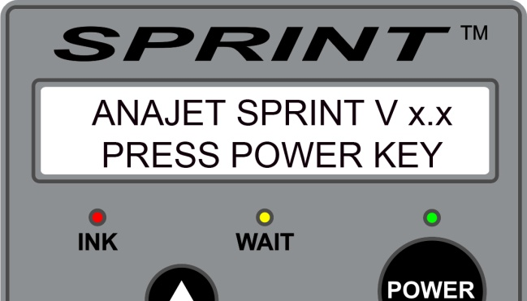

Figure 4.1: LCD During Power Up Sequence

This indicates the main power switch is on.

- Next press the Control Panel POWER key to turn on the print engine. It usually takes about one to two minutes for the print engine to complete the power up sequence. The Print Table will move forward to the Load Position. When the power up sequence is properly completed, the following display (in Figure 4.2) will show in the LCD.

Figure 4.2: LCD When Power Up Sequence is Complete

4. Power Down Sequence

The power down sequence is the reverse of the power up sequence.

- Press the control panel POWER key first. The print engine will go through the power down sequence. When power down sequence is completed, the LCD will display:

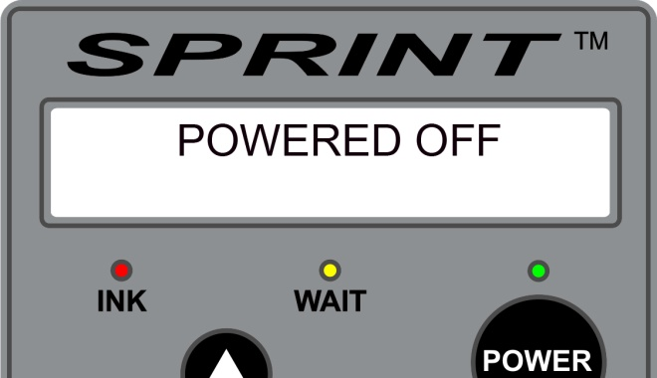

Figure 4.3: Power Down Sequence

The display will soon be replaced by ANAJET SPRINT V x.x PRESS POWER KEY.

- Next you can switch off the main power switch on the rear of the printer if you wish.

- Do not turn off the main power switch without powering down the print engine first. Otherwise the Print Head Carriage may not be properly docked with the Maintenance Station, causing damage to the system.

It is recommended that the print engine be kept powered on at all times, even if the printer is not used, unless the printer is loaded with cleaning solution and is in storage. Keeping the printer powered on prevents the Print Head from drying. A minimal amount of ink is used to keep the Print Head wet. If the Print Head dries up, the Head Cleaning operation will consume more ink than necessary to keep the Print Head wet during idle times. The dried Print Head may not recover. The best maintenance practice is to enable the Auto Print Head Maintenance while the printer is not in use. This requires the print engine to be powered on.

5. Moving Print Table

Pressing the TABLE key on the Control Panel will move the Print Table in one direction. Pressing the TABLE key while the Print Table is moving stops it. A third pressing will move the Print Table in the opposite direction. The forward most position is called the Load Position where garments are loaded. The far rear position is called the Home Position or Print Start Position. If the printer is shut down, the Print Table will rest in the Home Position. The TABLE key is functional regardless of the print engine being powered or not.

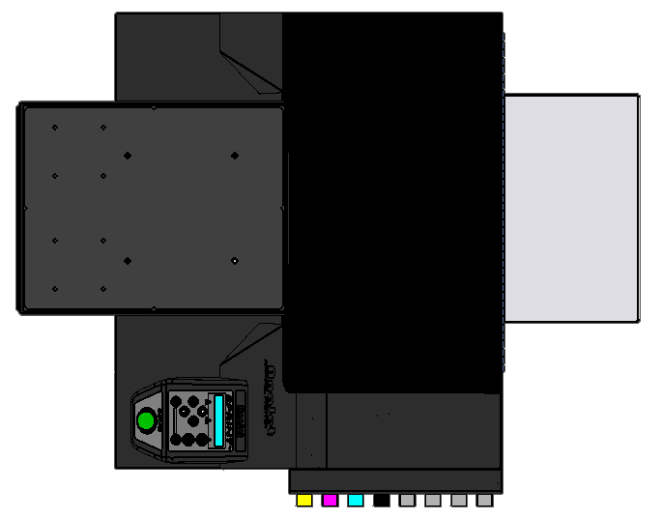
Load Position
Home Position

Figure 4.4: Print Table Positions at Each End

6. Adjustment of Print Table

The height of the Print Table is preset at the factory, and it is properly leveled before shipment. Normally no leveling will be necessary during operation. An uneven Print Table surface, however, will result in poor print quality or damage the printer.

The Print Table height is adjustable up to .8 inches. The proper height should be set depending on the thickness of the garment being printed. Proper Print Table height adjustment is very important. If the garment’s surface is too far from the Print Head Nozzle Plate, the print quality will suffer and ink over-spray may be visible. If it is too close to the Nozzle Plate, the garment will scratch and damage the Print Head Nozzle Plate coatings.

The optimal distance between the lowest point of the Print Head Nozzle Plate and the top surface of a loaded garment is in the range of .10 to .15 inches.

The Print Table height adjustment and leveling are done by the same procedure using the Gauge Block provided with the printer.

Figure 4.5: Gauge Block

The Print Table height is adjusted by turning the Nut on the Table Support. To turn the Nut, you must first loosen the Knob by turning it counter clockwise. To raise the Table, turn the Nut clockwise (when viewed from the top). To lower the Table, turn the Nut counter clockwise. You are unlikely in need of leveling the Print Table, but when necessary, the Print Table Leveling is done with the 4 Thumbnuts under the Table.

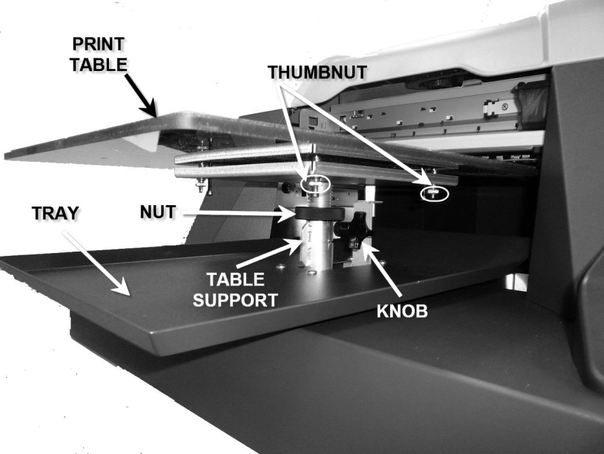

Figure 4.6: Print Table

Table Height Adjustment Process

- Move the Print Table back until the rear edge is under the Carriage Guide Bar (CGB). Take note that the Carriage Guide Bar is the round chrome bar.

Figure 4.7: Carriage Guide Bar, With Print Table Front Edge Under It.

- Lower the Print Table by turning the Nut until the Gauge Block fits under the CGB at both sides of the Print Table. (You must first loosen the Knob to be able to turn the Nut.)
- If the Print Table is not level with the CGB, loosen the Thumbnut under the lower side until the Print Table is level & the Gauge Block just touches the CGB.

- Check that the Gauge Block just touches the CGB on the other side.

- Move the Print Table back until the front edge is near the CGB.

- If the Gauge Block does not just touch the CGB, repeat steps 3 & 4.

- Move the Print Table forward until the rear edge of the Print Table is under the CGB.

- Recheck the fit under the CGB & readjust as required.

- This height is approximately the correct height for t-shirts. For other garments, you may adjust the height accordingly to make the distance from the top of garment to the Nozzle Plate to meet the optimal .10 - .15 inch.

Table Leveling Adjustment Process

You are unlikely in need of leveling the Print Table, since the factory-set level does not easily go out of alignment. Consult AnaJet Tech Support to confirm you need to. Note that the leveling the Print Table means that all sections of the Table are equally distant from the Carriage Guide Bar CGB. Thus the use of a carpenter’s level in not relevant.

Tools required: Gauge Block, pliers, Phillips or cross face (+) screwdriver (#2), Allen wrench (9/64).

- Using a Gauge Block, determine which corner(s) of the Print Table needs to be adjusted. Any of the four corners can be adjusted up or down.
- For any corner that needs to be adjusted, hold the gold knurl thumbnut under that corner with the pliers while turning the corresponding screw on the top side of the Print Table with the screwdriver. Tip: Make small adjustment increments at a time and check the Print Table’s level often.
  - If the corner needs to be raised, turn the screwdriver CCW (counter clock wise) until that corner is raised up to level.
  - If the corner needs to be lowered, first use the Allen wrench and turn the black screw under that corner CW (clock wise) to loosen and lower the screw. Then, using the pliers and screwdriver, turn the screw driver CW until that corner is lowered to level.
- Once a corner is leveled, use the Allen wrench and tighten down the black screw under that corner by turning it CCW. This will lock in that corner’s adjustment.
- Repeat Steps 2 and 3 for any additional corners that need to be adjusted.
7. Printing Operation

Prior to printing, make sure the Print Table is properly adjusted as indicated in the preceding section.

- Prepare the print file in the PC and send it to the printer through your graphics application program. Refer to Chapter 5: Printer Software for settings of the print program.

- Load the garment on the Print Table, and spread it flat. If the garment is not flat, the printer’s Obstruction Sensor laser will detect it and will stop printing until the obstruction or wrinkles are removed. The garment should be centered on the Print Table. You should be able to easily relate the position of the printing area with what you see in the application program’s print preview window. The maximum printable area is 12.5” x 16.0” which is the size of the Print Table. Place the Hoop over the garment to secure the garment if desired. For most garments, the use of a Hoop is not necessary.

- For printing youth size shirts, you can install a Youth Size Print Table which is 8.5”x12.0” in size, AnaJet P/N PT-850Y, or a Long Table which is 8.5”x16”, AnaJet P/N PT-850L (see Figure 4.9). When using these narrower tables, choose the corresponding table size in the printing software (Driver or EKprint Studio). Doing so will change the application’s preview window to correspond to the narrower print area as well as automatically adjust the print origin.

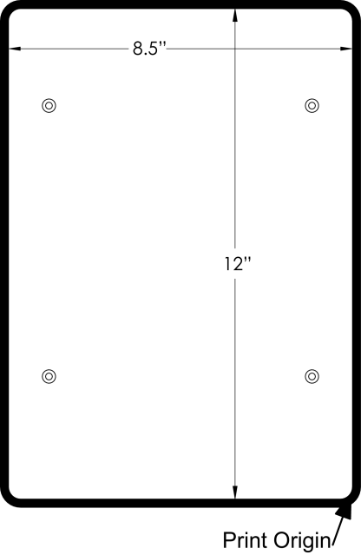

Figure 4.8: Long and Youth Size Print Table and Print Origin

- When the green Print Ready LED lights up, the printer has received a sufficient amount of data to start printing. Press the PRINT button. The Print Table will retract to the Home Position. To stop the table movement, press the CANCEL key. This only pauses the table and the job will still be waiting to print; pressing the PRINT button again will resume the printing process.

- When the Print Table reaches the Home Position (the Print Start position), the printing will start. Upon completion, the Print Table will move to the Load Position and the printer will beep if the printer’s audible signal is set to be active.

- Remove the [Hoop and] garment from the Print Table, minding not to touch the printed area. The printed area is still wet with ink.

- Fix the ink onto the garment with heat treatment. Place the garment on a heat press with the printed side up. Spread it flat on the heat press, minding not to touch the wet ink. Cover it with a sheet of AnaJet SoftTouch heat press paper, AnaJet P/N HPS-50. For AnaBright® ink, press the printed garment for 35 to 40 seconds at 356ºF or 180ºC with medium to heavy pressure. (See Figure 4.10 for time and temperature variations when using PolyBright™ ink.) A heat press with an auto release mechanism will pop open when the time is up, otherwise you will need to open the top platen. Remove the heat press paper immediately when the platen is opened. AnaJet SoftTouch heat press paper can be reused several times. Instead of SoftTouch, a Teflon pad can be used (for garments without white ink only). Some heat presses have an upper platen that is treated with Teflon. Make sure there are no wrinkles in the reused SoftTouch paper. The printed garment is now finished. If you reduce the heat press temperature, you must increase the time. If you are using a textile oven or conveyor dryer, you can set the temperature lower but you will have to increase the time considerably as shown in Figure 4.10. Heat treatment below 300 degrees F is not recommended.

AnaBright® Ink | Temperature | Time
Light Shirt with  Heat Press (1) | 356˚F or 180˚C | 35 - 40 seconds
Light Shirt with  Heat Press (2) | 330˚F or 165˚C | 90 seconds
Light Shirt with Conveyer Dryer (1) | 320˚F or 160˚C | 2 minutes
Dark Shirt with Conveyer Dryer (2) | 305˚F or 151˚C | 5 minutes
Dark Shirts with  Heat Press (1) | 330˚F or 165˚C | 90 seconds
Dark Shirts with  Heat Press (2) | 325˚F or 162˚C | 2 minutes
Figure 4.9: AnaBright® Ink Heat Curing Temperature and Time Variations

PolyBright™ Ink* | Temperature | Time
Light Shirt, Most Fabrics | 400˚F or 205˚C | 30 seconds
Light Shirt, Nylon | 360˚F or 183˚C | 30 seconds
*For detail, refer to PolyBright™ Ink Instruction sheet included in each yellow cartridge box.

Figure 4.10: PolyBright™ Ink Heat Curing Temperature and Time Variations

Tips on Printing on Shirt Pockets
- When printing pocket drop graphics, AnaJet’s Pocket Adapter, AnaJet P/N PKT-1, can be used to simplify the process. The 5.5” x 4.0” Pocket Adapter can be placed portrait or landscape on top of either side of the front of the Print Table. The exact offset measurements of the Pocket Adapter are shown in Figure 4.8. When printing with the Pocket Adapter, remember to adjust the Print Table’s height with the Gauge Block on the Pocket Adapter.

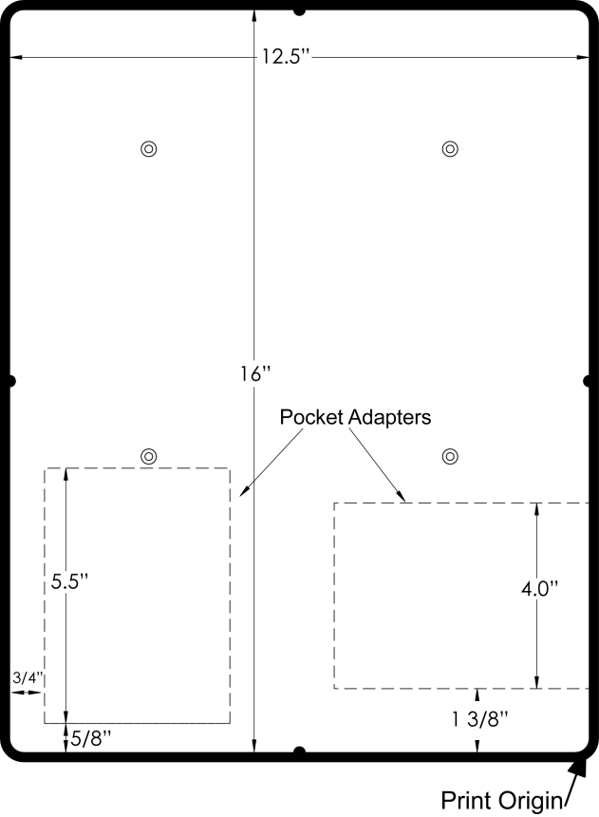
Figure 4.11: Print Table with Pocket Adapter Layout and Print Origin

8. Canceling a Print Job

While printing a garment, the Control Panel LCD displays:

PRINTER BUSY
CANCEL KEY AVAIL

While printing, you can cancel the print job by pressing the CANCEL key on the Control Panel. The printer will stop immediately. The Power LED starts blinking and the LCD displays:

JOB ABORTED. WAIT
TIL LED BLINK STOPS

The POWER LED will blink while the data is being cleared from the printer and computer. When the Power LED stops blinking, the LCD message will clear and you are ready to start the next operation. Depending on the job and Windows performance, it may take up to several minutes to clear the job after the CANCEL key is pressed. Be patient when you cancel a job. It is important not to operate the printer or send another job from the computer until the cancelled job is completely cleared, which is indicated when the POWER LED stops blinking. Otherwise it may be necessary to shut down both the print engine and the computer and reboot both. Larger images and files take longer to clear. If a multiple copy job is sent to the printer, be patient, it will take longer to clear than a single print file. Normally canceling a job should take less than a few minutes. If canceling is taking longer than 10 minutes, cancel the job(s) from the computer and restart the printer.

9. Obstruction Sensor

The Obstruction Sensor detects any obstruction on the Print Table, such as wrinkles on the shirts. Such obstructions can be mangled under the Print Head Carriage, which can damage the printer. The Obstruction Sensor is installed so that the red laser beam will be just below the lowest point of the Carriage. On the left-hand side of the printer, there is an Obstruction Laser Diode, which generates the laser. On the right-hand side, there is the Obstruction Laser Sensor.

WARNING: Although the laser used in the SPRINT printer is low power, exercise care so that the laser does not shine directly into any sensitive areas of the body such as eyes. The laser can cause critical injury.

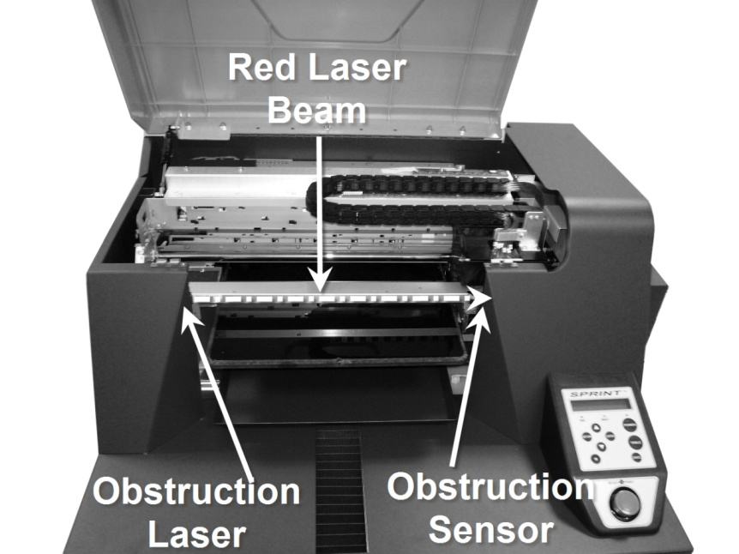

Figure 4.12: Obstruction Laser and Sensor

The Obstruction Sensor is active only while the Print Table is retracting to the Home Position (Print Start position) after the PRINT button is pressed. It is deactivated when the Print Table reaches the Home Position. Normally the Obstruction Laser Diode is off.

- If any obstruction is detected while the Print Table is moving to the Home Position (Print Start position), the Print Table stops. An audible warning signal as well as the following LCD display will appear. At this point the job will not be cancelled.

OBSTRUCTION ERROR
PRINT KEY WHEN CLEAR

- After you clear the wrinkles or other obstructions on the garment, press the PRINT button. The Print Table will resume its travel to Print Start position. If necessary you can use the TABLE key to bring back the Print Table to the load position so that you can clear the obstructions.

10. Auto System Maintenance

AUTO SYSTEM MAINTENANCE

The printer will automatically renew the system when necessary. During this time, the LCD will display:

PLEASE WAIT: AUTO
SYSTEM MAINTENANCE

The WAIT LED will blink. It takes approximately three minutes to complete the Auto System Maintenance routine. When the Auto System Maintenance routine is complete, the LCD will so indicate and the WAIT LED will go off.

If the printer goes into Auto System Maintenance during a print job, it will resume the printing operation to complete the current job. Do not interfere with the Auto System Maintenance routine. Do not attempt to give other commands to the printer or over-ride the Auto System Maintenance routine. Otherwise you may have to reboot the system.

Chapter 5 Printer Software

1. Built-in Raster Image Processor

AnaPrint SPRINT printing software is provided with the printer. AnaPrint SPRINT program consists of three parts: the printer driver, printer utilities and EKprint Studio. A raster image processor (RIP) is software which converts the graphic design to bitmap data suitable for printing. In the process, smoothing or interpolation algorithms are applied to the graphic data, ink drop size and exact placement of inkjet ink drops are determined. Thus the quality of the RIP program used affects the quality of print. Generally RIP programs are difficult to learn and operate in a production environment. AnaJet has licensed a powerful RIP program, optimized for apparel printing. The optimized RIP program is built into the AnaPrint program. Thus with the AnaPrint SPRINT program, no separate RIP operation is necessary and the software for light colored garment operation is very simple. The built-in RIP program automatically handles the data in the background and assures highest quality image without user intervention.

For dark shirt printing, the special RIP program, EKprint Studio, requires more interaction with the operator. If your SPRINT has the Dark Garment Print Option, EKprint Studio for SPRINT is provided as a part of your system. EKprint Studio will seamlessly interface with your favorite graphics application programs such as PhotoShop and CorelDraw. See Chapter 6, Printing on Black Garments for detail.

The SPRINT printer is also provided with the AnaJet SPRINT Utility Program, which handles more advanced and less frequently used utility functions.

There are two software methods of printing with an AnaJet SPRINT. The first method is to print using AnaJet’s Windows compliant printer driver. Users can print to the AnaJet SPRINT from their graphic program in a manner similar to any desktop printer.. Note that the driver method does not allow for printing with white ink, and is only available in the 32 bit versions of Windows operating systems.

The second is method is using EKprint Studio. EKprint Studio is a RIP program and such RIP programs are used on nearly all commercial printer applications. AnaJet SPRINT’s dark shirt printing can be done only with EKprint Studio.

2. Accessing the Printer Program and Page Setup

Accessing the printer driver and setting up the page are slightly different depending on the application software. Here the process is illustrated with the Photoshop Elements. The principles are the same with most programs and they are usually easy to follow.

- When the graphic and text design is ready in the application, click File/Print Preview. Then click the Page Setup button.

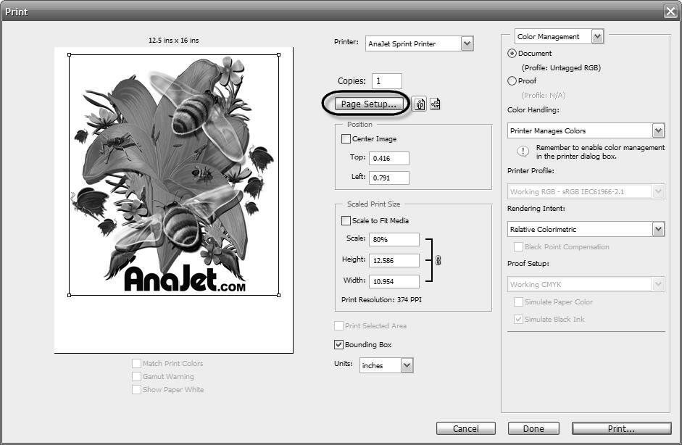

Figure 5.1: Typical Graphics Program Print Preview

- When the Page Setup window appears, click the Printer button. Then select AnaJet SPRINT as the printer of your choice. Click OK. You will return to the Page Setup window. Notice that with the selection of the AnaJet SPRINT printer, the Paper Size is automatically selected as 12.5” x 16.0”. Since your computer is most likely dedicated to the AnaJet SPRINT printer, once you select SPRINT as your default printer you will not need to go through this process again.

Click the OK button to return to the Print Preview window.

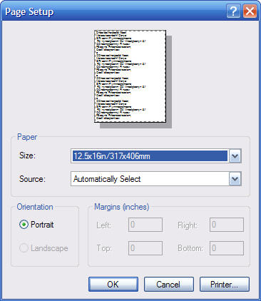

Figure 5.2: Typical Graphics Program Page Setup
- While you are still in the Page Setup window, if you click Landscape Orientation, your graphics will be turned around 90 degrees clockwise when printed.

- When you return to the Print Preview window, you have a number of options as to the size and position of the graphics.

  - The size of the print is indicated in Height and Width boxes. You can scale the print size; scaling up may deteriorate the print quality if there is not sufficient data in the design to support the larger size prints.

  - The white preview box corresponds to the SPRINT Print Table with the top of the box matching the top of the Print Table. An efficient method is centering the image by checking the Center Image box. Once the image is centered, you can move it up near the top by entering 0.1 or 0.2 in the Position/Top box.

  - An alternate way of positioning is to check the Show Bounding Box, then move the graphic around with the mouse in the preview window.

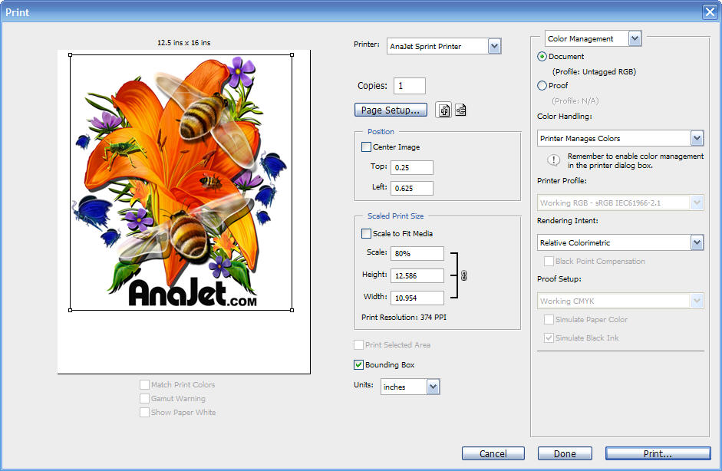

Figure 5.3: Typical Graphics Program Print Preview

- When the sizing and positioning are completed, click the Page Setup button to access the SPRINT Printer Driver for various ink setting related adjustments (which are explained in the next section). When all the ink settings are set, click the Print button to print the graphic.

3. Using the SPRINT Printer Driver

When the Page Setup button is pressed in the application’s print preview window, the AnaPrint SPRINT Printer Driver’s settings will appear. From here, various adjustments and utilities regarding the driver can be set and utilized.

- Paper/Quality tab
Leave it at the default “Cotton, knitted” and select the Color button. If you are printing with the Youth or Long Print Table, click on the Advanced button. From here, you can choose the different Print Table sizes. Note: whatever Print Table size is selected, the preview area in your print application’s print preview screen will change accordingly.

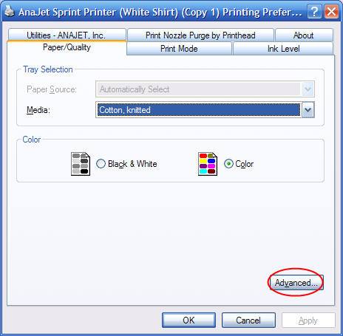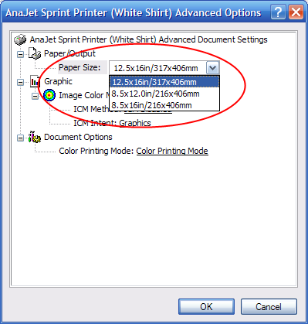

Figure 5.4: Default Media and Figure 5.5: Print Table Size
Color Selections

- Print Mode tab
The Print Mode window allows you to choose the color mode of the print. The following is a brief description of the three color modes:

  - Vivid: It generates enhanced vibrant color values to give color intensity. This is not the most accurate color, but it has a great deal of commercial value as many customers prefer vibrant colors in garment decoration.
  - Standard (default): It provides the most accurate colors, but does not have the same visual impact as the Vivid mode.
  - Photo: It prints high quality flesh tones and details, often valued in photo prints. [Note that this mode supersedes the Ink Drop Size control, and uses a smaller Ink Drop Size.]
- Ink Level tab
The Ink Level tab allows you to choose the optimal ink flow. Two factors determine the ink flow: the average size of Ink Drop and the Ink Level. Together they determine the total amount of inks used. For a similar level of ink flow, you can use a smaller Ink Drop Size at a higher Ink Level or a larger Ink Drop Size at a lower Ink Level. Depending on the application and fabric used, it will be necessary to adjust both the Ink Drop Size and the Ink Level. The drop size distribution of ink drops is determined by the application program and the built in RIP program and is beyond user control.

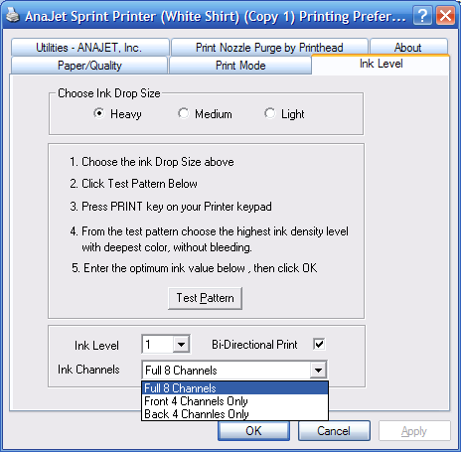

Figure 5.6: Ink Level and Printing Preferences

  - Choose Ink Drop Size: Your choice determines the average Ink Drop Size. Light jets a smaller Ink Drop Size, and Heavy jets a larger Ink Drop Size. For light weight fine fabric, choose the Light Ink Drop Size. Many fine polyester materials or fine woven cotton may fall into this category.

For medium weight fabric such as cotton tee shirt materials, choose the
Medium Ink Drop Size.

For heavier fabric such as sweat shirt, choose the Heavy Ink Drop Size.

  - Choose Ink Level: For each of the selected Ink Drop Sizes, there are five levels of inks. Level 1 is the smallest amount of ink and level 5 is the largest amount of ink.

  - The combination of the Ink Drop Size choice and the Ink Level is not absolute. You can use any combination of these two to attain optimal ink flow. For instance, Medium/Level 2 can be substituted by Light/Level 4 for more delicate designs with similar amounts of ink. Alternatively Medium/Level 3 can be substituted with Heavy/Level 1 for more robust prints.

  - When printing on a textile fabric you are not familiar with, it may be necessary to test the fabric with the Ink Level Test Pattern. See Section 4: Ink Test Pattern below.

  - Keep the Bi-Directional Print box checked to print fast bi-directional prints. Uncheck it for uni-directional printing which is slower. In certain cases the uni-directional printing may help keep crisp printing when the distance between the print head and fabric is farther than optimal.

  - Ink Channels: If your printer has YMCK + WWWW ink configuration, and if you wish to print on white or light colored garments using the front four channels of colored inks, you should select the Ink-Front 4 Channels Only box. If your printer is equipped with 2 sets of colored ink (YMCK + YMCK configuration), select full 8 channels. If your printer has color ink in the back four channels and you want to print with those only, choose Back 4 Channels Only.

  - For Utilities and Print Nozzle Purge by Print Head tabs, see relevant sections below.

4. Ink Test Pattern

When you print on a new garment fabric material, it is best to determine the optimal ink specification by printing a Test Pattern. To print an ink Test Pattern, click the Ink Level tab while in the AnaPrint SPRINT program, Printing Preferences window.

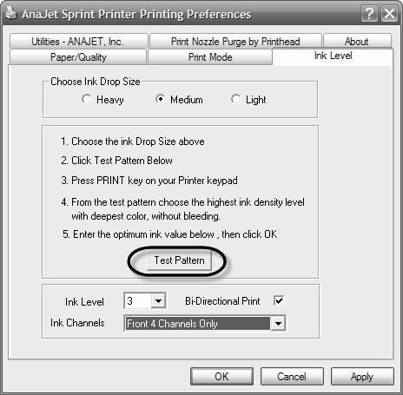

Figure 5.7: Printing an Ink Test Pattern

- First choose the Ink Drop Size based on your fabric and design. Again it does not have to exactly match the nature of your fabric. Even if your fabric is medium, you can choose to use Light for delicate designs or details, or vice versa.

- Load the exact fabric you plan to print on the center of the Print Table. Click the Test Pattern button, and follow the on-screen instructions. When the Print Ready LED lights up, press the PRINT button. When the print is completed, fix the ink onto the fabric using a heat press. After the heat fix, with AnaBright® ink the robustness of ink will usually decline slightly. With PolyBright™ ink the robustness of the ink will increase after a heat fix. Note that prints made with PolyBright™ ink does not appear like the intended color until they are heat treated.

- Closely examine the printed test pattern similar to the one shown in Figure 5.8. Choose the Ink Level which has the desired print effect with deepest and the most robust colors, without bleeding.

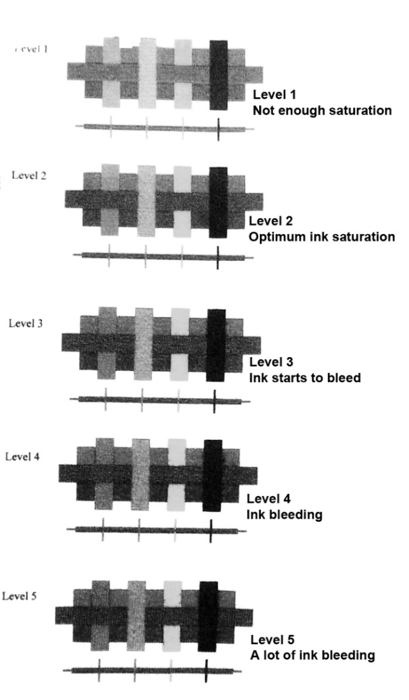

Figure 5.8: Ink Level Test Pattern Print

The ink Test Pattern you see is for the selected Ink Drop Size. You can print additional Test Patterns using a different Ink Drop Size if so desired. When you find an ideal combination of Ink Drop Size and Ink Level, make a notation for future use. Always test the fabric with an Ink Level Test Pattern when you use unfamiliar fabric. Sometimes even when you print on a fabric you believe you are familiar with, you can get unexpected results for a number of reasons, such as different weaving pattern or chemical coatings of the material by the garment manufacturer.

5. Using SPRINT Printer Utilities

From the AnaPrint print program, click the Utilities tab. There are four utilities available for the printer.

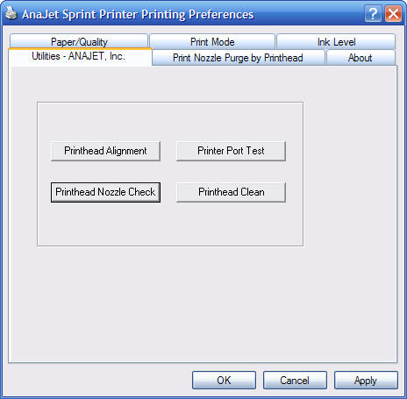

Figure 5.9: Printer Utilities Tab

- Print Head Nozzle Check

To check the Print Head Nozzles, click the Print Head Nozzle Check button. When the Nozzle Check dialog box opens, follow the on-screen instructions and click the Print button. Place an 8.5”x11.0” or larger size paper at the lower right corner of the Print Table. Press the PRINT button on the Control Panel when the Print Ready LED lights up. Examine the printed Nozzle Check pattern carefully. If it is not satisfactory, perform a Print Head Cleaning operation.

In the Nozzle Check print patterns shown below (Figure 5.10 and 5.11), the seven colored patterns correspond to ink channels 1 through 7. The checkered pattern is for the eighth channel. If you are using white ink, the last four channels will print the test pattern with the white ink. To see the white ink, print your Nozzle Check directly on the table.

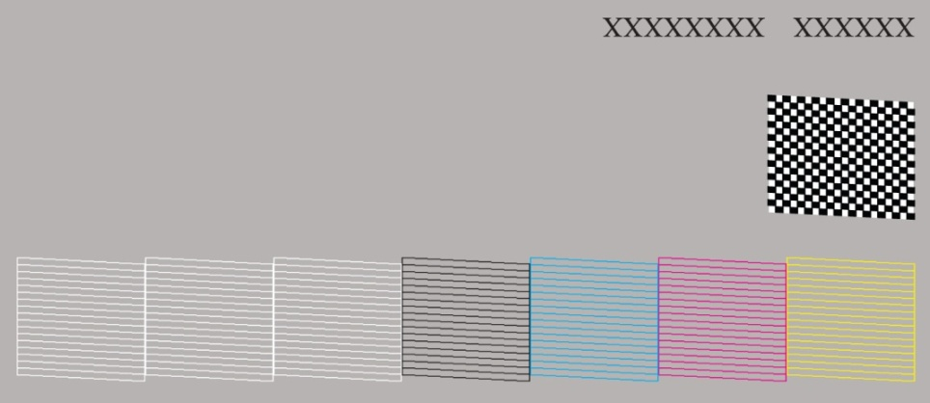

Figure 5.10: Good Nozzle Check

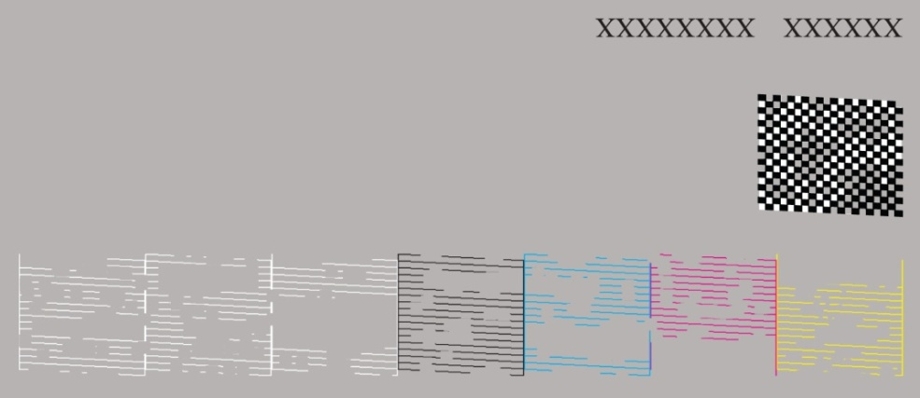

Figure 5.11: Poor Nozzle Check

- Print Head Clean

If the printed Nozzle Check pattern is not satisfactory (see Figure 5.11), it is necessary to perform a Print Head Cleaning Operation. Click the Print Head Clean button in the Utilities tab. The system will take over and clean the Print Head, which takes about 1 to 3 minutes depending on the status of the printer. It is a good idea to print the Nozzle Check pattern again, after each Print Head cleaning to see its effects.

Perform as many Print Head Cleaning Operations as needed, but preferably no more than four or five times consecutively. Too many head cleanings can make ink flow worse by developing air foam near the nozzle area. With AnaJet’s ink cartridges and closed loop ink delivery system, Print Head clogging will be minimal. Normally it should not require Print Head Cleaning Operations more than a few times a week if you are actively using the printer. Sometimes, particularly if you do not clean your Maintenance Station diligently or do not use the printer daily, more Head Cleaning may be necessary. If Head Cleaning does not resolve the Nozzle Clog, perform an Ink Charge function to clear the print head using the SPRINT Utility Program. (See Chapter 7 Maintenance, Section 6 AnaJet SPRINT Utility) Do not perform more Print Head Cleaning Operations than absolutely necessary. Over cleaning will cause air foam to develop near the Print Head, blocking good ink flow. It takes time for the air foam to settle and allow ink flow again. Instead of additional head cleaning, you can use the Purge Print utility explained below.

If you continue to have poor Nozzle Check patterns after three Print Head Cleaning Operations, or if you need frequent Print Head cleaning, there may be other issues. You may need to clean the Maintenance Station or the outer edges of the Print Head. You may have a permanently clogged Print Head Nozzle which is usually the result of continued neglect to clean and maintain the printer. The operating room may have too low humidity accelerating the Print Head Nozzle dry out. Refer to the relevant sections of maintenance and trouble shooting in this manual.

Never send a print job from the computer or press Control Panel keys until the Print Head Cleaning Operation is completed. The printer can lock up and you may have to reboot the printer.

- Print Head Alignment

When the Print Head is out of alignment, you will experience poor print quality or the prints may become “fuzzy.” When you change the distance between the print material surface and the Print Head Nozzle Plate, you will also need to re-align the Print Head. This normally happens when adjusting the Print Table height for different garment thicknesses. If you notice print quality decline without any apparent reason, perform the Print Head Alignment.

Click the Print Head Alignment tab while in the Utilities window. Load an 8.5x11.0”
or larger size paper on the lower right corner of the Print Table. When the Print Ready LED lights up, press the PRINT button.

Upon printing the alignment pattern, examine the alignment pattern carefully. For
each of the three sets of test patterns, select the square without visible white band or the least amount of band. Enter the value in the corresponding dialog box (see Figure 5.12). Follow the on-screen instructions. If the selected squares have no band, and you are satisfied, click the Finish button. Otherwise click the Realignment button to re-align the head. You can realign as many times as necessary. If the print head is badly out of alignment, it may take several iterations.

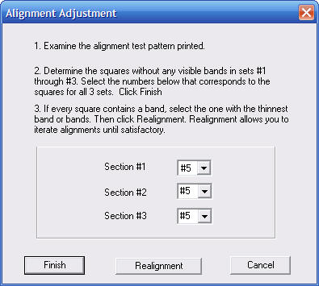

Figure 5.12: Print Head Alignment Adjustment

- Printer Port Test

The Printer Port Test is used to test if the communication between the computer and the AnaJet SPRINT printer is properly established. Click the Printer Port Test button, while watching the printer Control Panel Power LED. The Power LED will blink a few times if the communication is established. If there is no communication, refer to Chapter 8: Troubleshooting.

6. Print Nozzle Purge by Print Head

This function is used for testing ink flow as well as to purge the Print Head Nozzles.

- Click the Print Nozzle Purge by Print Head tab (see Figure 5.13).
- Follow the on screen instructions.
- From the drop down list, select any one of the eight ink channels to purge. These are in the sequence of the ink channels, i.e. the first four channels (“Print Heads”) of Yellow, Magenta, Cyan and Black. Next are the fifth through eighth channels (“Print Heads”) of the second set of Y M C K or white inks if white ink cartridges are installed in these channels.
- Click the Purge-Print button to purge the selected channel.
- Load an 8.5x11.0” or larger size paper at the lower right corner of the Print Table.
- When the Ready LED lights up on the Control Panel, press the PRINT button.
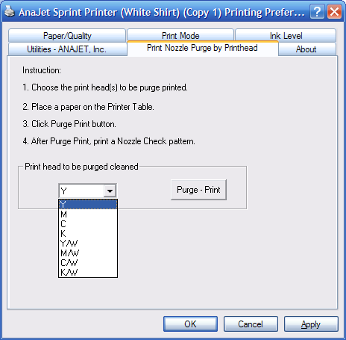

Figure 5.13: Print Nozzle Purge by Print Head

Chapter 6 Printing on Black Garments

1. Basic Black Garment Printing Process

The black and dark colored garment printing principle is essentially the same as white garment printing with added procedures. Refer to the basic white garment printing process prior to learning the black garment printing process. This chapter addresses only those features unique to black garment printing. The basic process is as follows:

(1) Pre-treat the garment with AnaJet Pre-treatment Liquid, preferably with an AnaJet Pretreatment System. You only need to pretreat the area you will print on.
(2) Dry the pre-treatment; press garment for several seconds once dry.
(3) Place the dark garment on the Print Table.
(4) Send the print job from the PC, using the AnaJet dark garment print RIP program.
(5) Press the PRINT button when the Print Ready LED lights up to print the white ink
undercoating.
(6) When white ink undercoating is completed, press the PRINT button again when the
Ready LED lights up to print the color layer.
(7) Upon completion of the print, fix the ink onto the garment with a heat press.

The dark garment printing with white ink is a more involved process than light-colored garment printing. This is particularly true with the print data preparation and print settings. It may be very desirable for the operator to practice many times before he starts using the system for commercial printing of dark garments for customers.

2. Maintenance of Printers with White Ink

Although AnaBright® white ink performs better than any other competitive products for printing dark shirts and AnaJet SPRINT printers require less maintenance compared to other printers, today’s direct to garment white inks still require a fair amount of maintenance. (See the Technical Notes in Section 3 below.)

Due to a higher concentration of solids and heavier white ink pigments, white ink can clog the Ink Delivery System and Print Heads. When white ink cartridges are installed in the printer, a more frequent head cleaning and maintenance operation is necessary.

The garments should never touch the Print Head or Nozzle Plate as it can scratch the Nozzle Plate Coating or cause clogging of the nozzles. This is particularly true when printing with black garments sprayed with Pre-treatment Liquid. Adjust the Print Table height so that the garments will not touch the Print Head Nozzle Plate.

The periodic printer maintenance takes an added importance when the printer is used for dark garment printing. The white ink contains a higher percentage of solids than colored inks, resulting in more ink residues accumulating on and around the Print Head, Wiper Blade and Maintenance Station. When white ink is used, the white residues accumulating around the Maintenance Station and Nozzle Plate cause the Maintenance Station not to seal properly during cleaning cycles. The pretreatment applied to the garments also leaves residues on the Print Head area. All this accumulation of foreign materials will tend to clog the Print Head and shorten its life unless the residues are removed regularly.

3. Scheduled Maintenance for Printers with White Ink Installed

For those printers with White Ink installed, it is very important to follow the printer maintenance schedule below on a regular basis. If continually neglected, it will be necessary to ship the unit back to AnaJet and put the printer through an extensive and expensive refurbishment process.

DAILY:

1. Using the AnaPrint SPRINT drive program utility, print nozzle check daily printing directly on the Print Table. Perform the Print Head Clean as needed. Usually one or two Print Head Cleans will clear the nozzles and provide a good Nozzle Test Pattern. Do not use the Print Head Clean function more than necessary. Too many consecutive Print Head Clean Operations will cause development of air foam, blocking ink flow. See Chapter 5: Printer Software, Section 5: Using SPRINT Printer Utilities. One can also set Auto Print Head Maintenance from the printer’s control panel so that no daily action is required on the user’s part.

Note: Generally each of the 4 white ink channels must have 80% or better Nozzle Check Patterns to get acceptable print quality.

2. If you do not use white ink often enough or use the white ink heavily, it may be necessary to do the weekly maintenance on a daily basis or more frequently than once or twice a week.

WEEKLY (Once or Twice):

1. Check the Wiper Blade and the Maintenance Station for ink residues and clean them as necessary with an AnaJet Cleaning Applicator. You may need to clean them more than once or twice a week depending on your usage pattern. See Chapter 7: Maintenance and Transportation, Section 4: Cleaning Maintenance Station and Nozzle Plate.

2. Remove all 4 white ink cartridges and shake them a few times gently. Do not shake the cartridges vigorously as any trapped air inside the cartridge can cause aerating of the ink, resulting in poor ink flow. Replace them in the same ink bays.

Technical Notes on White Ink Maintenance:

Virtually all white inks used in digital apparel printers today are based on Titanium Dioxide which is a relatively heavy material. For direct to garment printers using Titanium Dioxide based White Inks, the following three conditions have to be met to make the inks continue to flow in the inkjet printer system:

(1) The inks (either in cartridges or bottles) must be agitated daily. This involves
gentle shaking of the cartridges or bottles.

(2) The inks must flow vigorously through the ink delivery system frequently. This
involves daily printing with white ink or head cleaning once or twice a week.

(3) The inks must not touch open air; otherwise the Titanium Dioxide based ink will
agglomerate and clog the ink delivery system and print head. Printers using
sealed ink cartridges can protect inks. Open ink bottles or refillable bulk ink
cartridges will expose the ink to open air causing agglomeration.

AnaJet SPRINT uses a Closed-Loop Ink Delivery system with sealed ink cartridges and can easily avoid inks’ exposure to air. However, the system operator still must shake the ink cartridges several times a week or at least weekly, and make the inks move through the ink tubes daily. SPRINT’s Auto Print Head Maintenance function set properly can reduce the manual maintenance tasks, but the operator needs frequent checking and provide needed additional manual maintenance.

AnaJet AnaBright white inks have seen significant improvements from the original white ink released in early 2007. As we improve the white ink for more user friendliness in the future, we expect the improved inks will continue to be provided in the AnaBright white ink cartridges for your easier maintenance.

MONTHLY:

1. Replace all white ink cartridges with Cleaning Solution cartridges and perform the Ink Charge from the AnaJet SPRINT Utility program until all the white ink in the tubes is replaced by Cleaning Solution. Let it sit overnight.

2. Reinstall the ink cartridges and perform the Ink Charge function until the Cleaning Solution is completely replaced by white ink in the tubes.

3. Check the left drip pan Ink Drip Foam for excessive buildup or saturation and replace or clean as necessary.

4. Using a Cleaning Applicator, clean the Maintenance Station and Wiper Blade as well as the edges of the Print Head Nozzle Plate as described in Chapter 7: Maintenance and Transportation. Never directly clean or touch the Print Head Nozzle Plate. This can cause permanent damage.

5. Check the Waste Ink Tank and drain as required.

If a printer loaded with white ink is not going to be used for more than three days, it is recommended to replace the white ink with Cleaning Solution until the white ink is needed.

Reproduce and use the WHITE INK SYSTEM MAINTENANCE CHECK LIST included in the Appendix.

4. In Case You Cannot Perform Regular Maintenance

Do not be concerned if you cannot perform the daily white ink maintenance over the weekend.

If you are not able to do the recommended regular maintenance for more than three days, due to holidays, vacations or because you ran out of ink in the ink cartridges and new cartridges are not available, it can cause problems. If you will not use the printer for more than three days or cannot provide the needed maintenance, replace the inks in the printer with Cleaning Solution.

When you return from holidays or are ready to use the printer again, replace the Cleaning Solution with inks. Now, do not neglect to perform the regular maintenance as needed.

5. Handling of Unused White Ink Cartridges

Prior to installation of AnaBright® ink cartridges in the printer, always gently shake the cartridges several times. (Shaking of the cartridges is not recommended for Cleaning Solution and PolyBright™ Inks.)

Store unused white ink cartridges in an environment indicated on the cartridge. Pay particular attention not to allow the ink to freeze. Gently shake or turn over the cartridges several times a week during storage. This will prevent possible settling of solids in the white ink. Do not be concerned if you cannot shake the cartridges over the weekend or during a short vacation.

6. Pre-treatment of Dark Colored Garments.

Pre-treatment Liquid is to be used with care. Do not let it contact your eyes. Do not breathe the vapor or mist. Thoroughly wash your hands after handling it. If the clothing gets contaminated, wash it before reuse. Follow the Caution and First Aid instructions on the Pre-treatment Liquid bottle label.

For dark garment printing, the most critical process is proper application of Pre-treatment Liquid onto the garments. Spotty or improper application of the Pre-treatment Liquid or improper drying process will result in white ink not bonding properly with the garment fabric. This will cause poor image quality and premature wash out of the ink.

You will need the following for pre-treatment.

- A well ventilated room. Good ventilation is essential for worker comfort and health. Application of Pre-treatment Liquid outdoors is not recommended on windy days as it can cause uneven application. It is recommended that a room be dedicated to the spray of pre-treatment so that the spray will not contaminate other materials. If this is not possible, we recommend the use of an AnaJet Pre-Treatment Booth. This will contain any overspray or vapors that may occur. Do not spray near the AnaJet printer as the fine spray can interfere with the printer operation.

- A good way to apply the Pre-treatment Liquid is to use a high volume low pressure (HVLP) spray gun. Such pray guns are commonly used for applying paints. These are available from paint supply stores or home improvement stores. Wagner Control Spray Gun and Campbell Hausfeld Paint Sprayer are some of the popular brands. This is also the recommended tool when using the AnaJet Pre-Treatment Booth.

Image 6.1: Wagner Control Spray Gun

Spray Process:

(1) Dilute the AnaBright® Pretreatment Liquid with an equal amount of distilled water (50%/50% mixture). You can use 60% water to 40% Pretreatment Liquid for a more even spray. Fill the sprayer reservoir with the mixture. It is very important to use distilled water (bottled water labeled as “distilled water”), as city water or filtered water has too much mineral contents to give good results.

(2) Hang the garments inside the AnaJet Pre-treatment Booth or lay them down on a flat spray table.. Make the garment even and flat.

(3) Spray the pre-treatment mix with the sprayer. Apply an adequate and even amount. Only spray on the areas that will be printed on. It is most important to spray lightly and evenly. Do not over-spray. You should never leave any spot uncovered.

(4) Optionally you can use a plastic squeegee to help spread the pre-treatment evenly after spraying.

(5) Dry the garment using a heat press, blow dryer or a heat tunnel. You can also achieve an excellent result by letting the garments air dry. It is recommended to briefly heat press the garment with AnaJet SoftTouch heat press paper before printing. The heat press will provide a smooth even surface after wetting.

Test with a few shirts to determine how much to spray. Too much pre-treatment can leave stains on the garments. Too little pre-treatment can make the prints look dull. This is one of the most common problems encountered in dark garment printing. The performance of white ink is highly dependent on proper application of pre-treatment. Too much or too little pre-treatment both cause the prints to wash off prematurely.

7. Printing Dark Garments

Since white ink and color inks are printed in separate passes, be careful not to push or
touch the Print Table during printing to cause registration problems. For dark garment printing, the use of a Hoop is highly recommended.

- Load a dry pre-treated garment on the Print Table and place the Hoop over it.

- Launch EKPrint Studio for SPRINT and load your graphic into the program.

  - An alternative method of loading your graphic into EKPrint Studio for SPRINT is to start from an application program such as Photoshop or CorelDraw. Load your graphic in your application program, then “print” your graphic into EKPrint. This can be done by printing your graphic from your graphic application but choosing the EKPrint RIP driver instead of a printer. Doing this will launch EKPrint with your graphic loaded. A detailed explanation of this can be found in Appendix 4: EKPrint Studio for AnaJet SPRINT Manual.

- After the white underbase printing is completed, press the PRINT button again once the Print Ready LED is on to print the color layer.

- Fix the ink onto the garment by heat treatment. Place the garment on a heat press. Cover it with AnaJet SoftTouch heat press paper. Set the heat press at 330 degrees F and press for 90 seconds with medium to high pressure. When the heat press upper platen is opened, remove the heat press paper immediately. The heat press paper can be reused a few times. Instead of heat press paper, you can use Teflon pad. But the use of Teflon pad leaves semi-glossy look to the prints. If you are using a conveyor dryer, cure it for two minutes at 325 degrees.

White Ink Level Setting

The EKprint Studio program will allow you to set the level of white ink. It is very tempting to set the white ink level high so that the resulting image will have brighter colors. This is very undesirable.

Leave the white ink setting in EKprint Studio at the default level. It is best to set the white ink level at a relatively low level to produce the best results.

High white ink level is the source of many problems. Prints with high white ink level will not resist washing; the combination of high white ink level and a larger image may not complete a print job within the available ink resource level; intensive use of white ink is hard on the print head; high ink level leaves more ink residues requiring more printer maintenance; at a higher white ink level, the per shirt white ink costs can be high.

8. Dark Garment Washing

The main drawback of dark garment prints is, after repeated washing, it may not match the durability of white garment prints which can match or exceed screen printed garments. But a properly printed dark garment can last dozens washes without noticeable fading if washed properly. Remember that the most important process for long lasting dark garment print is proper pre-treatment. If there are repeated problems with the durability of dark garment prints, review your pre-treatment process. We recommend printers to include the following washing instructions for the garments printed with white ink.

Washing Instructions for
longer lasting prints.
a. Turn the shirt inside out.
b. Wash in cold water.
c. Dry on delicate cycle.

Chapter 7 Maintenance and Transportation

1. Basic Maintenance Utility

For the printer’s basic every day maintenance utility functions, such as Nozzle Checks, Print Head Cleaning, etc., refer to Chapter 5: Printer Software, Section 5: Using SPRINT Printer Utilities. For maintenance specific to machines with white ink installed, refer to Chapter 6: Printing on Black Garments, Section 2: Maintenance of Printers with White Ink, and Section 5: Handling of Unused White Ink Cartridges.

The SPRINT printer has a built-in Auto Print Head Maintenance feature, which reduces the manual maintenance. To access the Auto Print Head Maintenance, press the Down Arrow key on the printer Control Panel. Then, set the maintenance frequency. Possible intervals for Auto Print Head Maintenance are:

- Every 3 days
- Every 2 days
- Every day
- Every 16 hours
- Every 12 hours
- Every 8 hours
- Every 4 hours
- Disabled
The recommended minimum setting is every 12 hours; 8 hours is preferable for printers with white ink installed. Refer to Chapter 3: Controls, Section 5: LCD Display.

The Auto Print Head Maintenance counts down from the last printer activity. Any printing will reset the time countdown. Note: The printer must be left powered on for the Auto Print Head Maintenance to function.

2. Replacing Ink Cartridges

The control panel Ink LED and LCD display indicate when an ink cartridge needs replacement. When the Ink LED blinks and the LCD display prompts to replace an ink cartridge, check the ink bay ink LED panel. Replace the cartridge as soon as possible.

The ink cartridges are filled with about 110ml of ink and provide a minimum of 100ml of usable ink. When the ink in a cartridge reaches approximately 5-10 milliliters, the ink out switch will be activated causing the ink LED to blink. It is not possible to extract all of the ink from the cartridge. The ink cartridge should be replaced as soon as the ink LED starts blinking. If the LED starts blinking during a print job, the current job can be finished without any problem. Continued use of the cartridge after the LED starts blinking can introduce air to the ink delivery system, and can cause damage to the printer.

If an ink LED remains on steady, either the ink cartridge is not installed or installed improperly. If improperly installed, pull out the cartridge and insert it carefully but fully until it stops. Do not force the cartridge to avoid damage to the printer. Without installing all eight cartridges, the printer will not print.

When all cartridges are present, the printer will operate and print even if one or more cartridges are low in ink or out of ink. It is the operator’s responsibility to replace the ink cartridges when the ink out LED blinks.

Even when you do not use the printer for an extended period of time, do not remove the ink cartridges from the printer. Even if the ink cartridges are empty, keep the cartridges installed to help keep the ink delivery system from drying. For storage for an extended time period, it is recommended to replace the inks with Cleaning Solution.

AnaJet recommends the use of genuine AnaJet AnaBright® or PolyBright™ ink cartridges which are developed for the intended application. Use of other inks or tampering of the ink cartridge will not only produce poor quality prints, it may cause damage to the printer which may not be covered by AnaJet warranty.
When you do not have a replacement cartridge, leave the old cartridge in the printer until you are ready to replace it with a new one.

To replace ink cartridges:

(1) Determine which cartridges need replacement by reading the LED indicator lights on the Ink Bay. Those which require replacement will blink.

Figure 7.1: LED Indicator Lights on the Ink Bay

(2) Carefully pull the empty cartridge straight out of the Ink Bay. The LED will turn solid on and the printer will beep indicating a cartridge is missing.

If any ink gets on your hands, wash them thoroughly with soap and water. If ink gets into your eyes, flush them immediately with clean water. Never taste the ink or place drops of ink in your mouth.
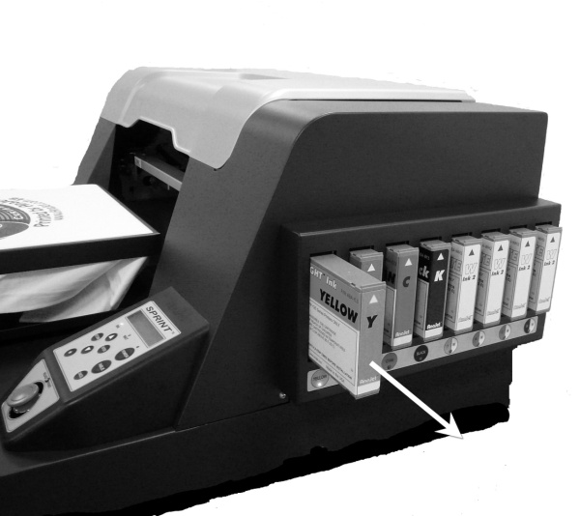

Figure 7.2: Pull the Cartridge Straight Out

(3) Make sure the replacement ink cartridge is of the correct color and is not expired. Colored inks expire in one year after the indicated manufacturing date; and white ink in six months from the indicated manufacturing date. The expiration date may be indicated on the cartridge instead of manufacturing date. Expired inks can clog the Ink Delivery System and may produce incorrect and less vibrant colors. Cleaning Solutions expire in three years after the manufacturing date.

(4) Gently shake AnaBright® ink cartridges a few times. PolyBright™ inks and AnaBright® Cleaning Solution cartridges should not be shaken.

(5) Hold the cartridge with the proper orientation. There is an “up arrow” on the front-side and “insert-this end” arrow on the side of the cartridge. Carefully insert it into the proper Ink Cartridge Bay. Push it in all the way with a firm motion. Do not force it to avoid damage to the printer. When it reaches the proper position, the indicator LED will turn off and you will also hear a beep. If the LED does not turn off, the cartridge many not have been installed correctly. Remove the cartridge and reinsert as described above.

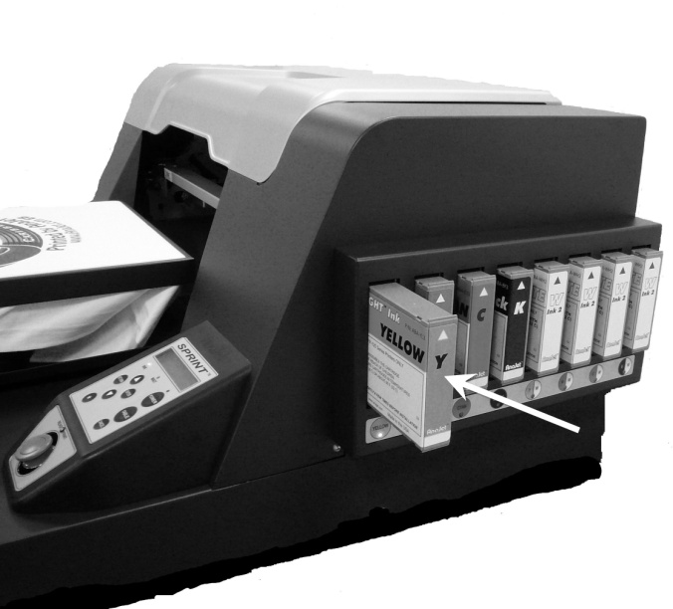

Figure 7.3: Push a New Cartridge Straight In

(6) Discard the used cartridges per your local regulations. Never dismantle, tinker with or attempt to refill the used ink cartridges. Refilled ink cartridges can clog the Ink Delivery System and Print Heads.

Partially used ink cartridges should be stored vertically with the receptacle upward, according to the direction indicated in the cartridge.

3. Switching from One Type of Ink to Another

There are times when you might need to switch the type of ink in your printer. Some examples are:

- Switching from AnaBright® ink to PolyBright™ ink and vice versa.
- Reconfiguring a printer with all colored ink cartridges to color and white inks for white and black garment printing and vice versa.
The general process for any type of ink switching is to first replace inks with Cleaning Solution to flush the Ink Delivery System, then replacing the Cleaning Solution with the new type of ink. This will prevent contamination of ink cartridges. The following is the step-by-step procedure:

a) Replace all Ink Bays that will be getting a different type of ink with Cleaning Solution cartridges.

b) Power down the printer. Using the printer’s ink pump, fill the ink tubes with cleaning solution. You may review this process in Chapter 1, Section 8 “Filling via Ink Pump”.

c) Replace the Cleaning Solution cartridges with the new ink type cartridges.

d) Use the Ink Pump Function again. As before, be sure to have the print cover open so you can observe that the inks are being charged completely through the Ink Tubes, all the way to the Print Head.

e) Power on the printer and perform a Head Clean and Print Head Nozzle Check to verify that all the new ink is through the Print Head.
- If the new ink installed in the printer is color ink, print the Nozzle Check on a piece of white paper.
  - If the Nozzle Check Patterns corresponding to the ink channels with the new color ink printed with faint or no color, repeat Step e.
  - If the Nozzle Check Patterns corresponding to the ink channels with the new color ink printed with solid colors, the ink switching process is complete.
- If the new ink installed in the printer is white ink, print the Nozzle Check directly on the Print Table.
  - If Nozzle Check Patterns corresponding to the ink channels with white ink printed with faint or no white, repeat Step e.
  - If the Nozzle Check Patterns corresponding to the ink channels with white ink printed with solid white, the ink switching process is complete.

When you install two sets of colored inks, whether they are AnaBright® or PolyBright™ inks, the colors need to be in the order or Y, M, C, K as shown in the Fig 7.4 below. When you configure the printer with colored ink and white ink, it is necessary to install the colored ink in the front four channels, with white ink cartridges in the rear four channels as shown in Fig 7.4. A typical situation will call for installation of AnaBright® colored inks in the front four channels, with white ink in channels 5 through 8. When you need to install PolyBright™ inks temporarily, you may want to install them in the front four channels. After the polyester printing is completed, you can replace the PolyBright™ inks with AnaBright® colored inks.

Ink Bay | Bay 1 | Bay 2 | Bay 3 | Bay 4 | Bay 5 | Bay 6 | Bay 7 | Bay 8
For White  Garments Only | Yellow | Magenta | Cyan | Black | Yellow | Magenta | Cyan | Black
For White and Black Garments | Yellow | Magenta | Cyan | Black | White | White | White | White

Figure 7.4: Ink Cartridge Order

4. Cleaning Maintenance Station and Nozzle Plate

Inkjet printers used for apparel printing require a higher level of maintenance than those used for document printing. Greater rate of ink flow, lint from garments, ink pigments and chemicals from Pre-treatment Liquid all contribute to accumulation of foreign elements in the Maintenance Station, Wiper Blade and Print Head areas. If not cleaned out regularly, these residues will interfere with ink flow, resulting in lower quality prints and shorter life of the Print Head. Wear powder-free latex or rubber gloves during cleaning if desired.

It is recommended to clean the Maintenance Station and Wiper Blade every week for printers with colored inks only. If white ink cartridges are installed, the ink residues will accumulate at a faster rate, and may require more frequent cleaning. Follow the maintenance schedule listed in Chapter 6: Printing on Black Garments, Section 2: Maintenance of Printers with White Ink. Make a record using the Maintenance Check List included in Appendix 2. The entire cleaning operation will take no more than 5 to 10 minutes.

Before a cleaning operation, obtain AnaJet Cleaning Applicators. These are low lint urethane cleaning swabs made for AnaJet maintenance cleaning. AnaJet P/N CA-WD1 (wide tips), CA-NR1 (narrow tips). Discard soiled Cleaning Applicators and always use a new one.

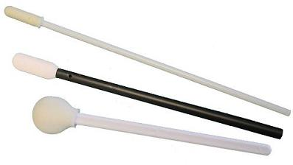

Figure 7.5: Cleaning Applicators

Cleaning Procedures:

- Power off the Print Engine. Open the printer’s top cover, but leave the Main Power Switch on.
- Locate the Maintenance Station below the Print Head Carriage.

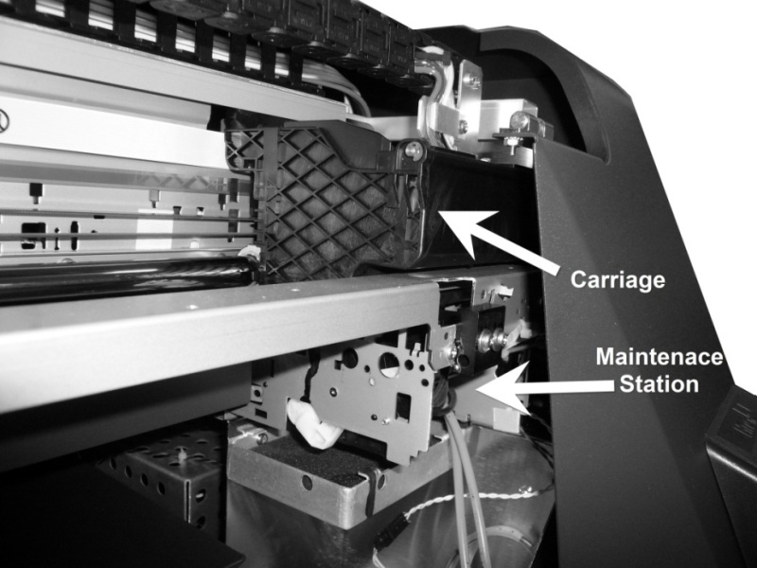

Figure 7.6: Carriage and Maintenance Station

From the Main Menu in the LCD you can access the instructions for unlocking the Print Head Carriage as shown below LCD display.

Figure 7.7: Unlocking the Print Head Carriage LCD

- Press the Down Arrow and ENTER keys simultaneously to unlock the Print Head Carriage from the Maintenance Station.
- Push the Print Head Carriage to the left of the Maintenance Station.
- Press the Down Arrow and ENTER keys simultaneously a second time; this will raise the Wiper Blade.
- Using Cleaning Applicators, gently clean around the Maintenance Station and the Wiper Blade. It is important to clean the edges of Maintenance Station which couples with the Print Head Nozzle Plate to form an airtight seal during cleaning operations. Clean both sides and top of the Wiper Blade, with care so that surrounding items will not be damaged. Remove as much of the accumulated ink residues as possible. The Cleaning Applicator can be dipped in AnaJet Cleaning Solution (AnaJet P/N CF-FT125) if there are dried ink deposits in the area. To avoid contamination, never dip soiled Cleaning Applicators in the Cleaning Solution bottle. Always use a new applicator. Do not use any sharp objects to remove dried ink deposits.

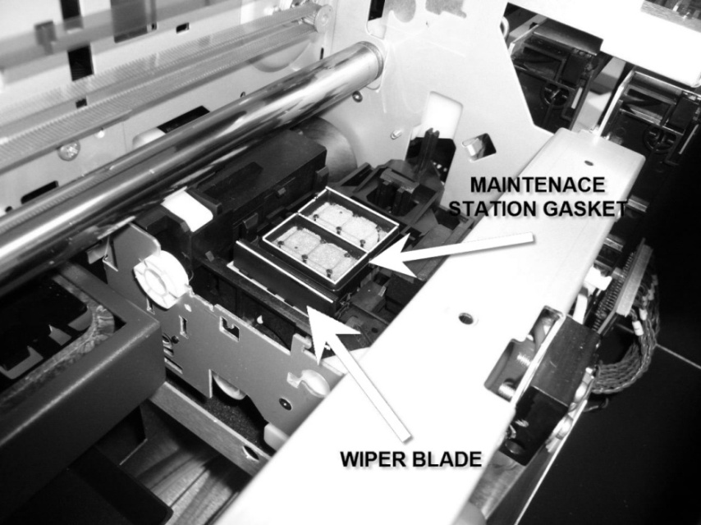
Figure 7.8: Clean Highlighted Areas with Swabs
- The Print Head Nozzle Plate is located below the Print Head Carriage. While the Carriage is still out to the left, gently clean the Nozzle Plate edges with a new Cleaning Applicator. Clean the residue accumulated only on the edges of the Nozzle Plate. Do not touch the Nozzle Plate itself. Extreme care must be exercised when cleaning the Nozzle Plate edges so as not to scratch or dent the Nozzle Plate. The Nozzle Plate is easy to dent and has a delicate thin coating which can be scratched. If dented or scratched, the Print Head becomes unusable.

Figure 7.9: Print Head Nozzle Plate

- Once all the cleaning is completed, replace the ink cartridge in ink bay four.

- Press the Control Panel POWER key. The printer will automatically place the Release Gear in the right position and park the Carriage in the Maintenance Station. Do not attempt to place the Release Gear by hand.

5. Waste Ink Tank and Ink Drip Foam

- The printer’s waste inks are collected in the Waste Ink Tank, located below the Maintenance Station. It needs to be empted when the Waste Ink Sensor is triggered. When the Waste Ink Tank is full, the LCD display will show “WASTE INK FULL / PLEASE DRAIN” and the printer will beep once. Waste ink is emptied through the Waste Ink Drain. Follow the procedure below:

  - Remove the Waste Ink Drain Tube from the storage area on the left side of the printer, under left drip foam.
  - Insert the Waste Ink Drain Tube into the Waste Ink Drain, on the right-side of the printer.
  - Remove the Rubber Stopper from the vent hole on the top of the Waste Ink Tank. Waste ink will flow out of the Waste Ink Drain Tube.
  - Empty into an appropriate container.
  - Dispose the ink according to your local regulations. Do NOT discard the waste ink into the city sewer.
  - After draining, reinsert the Rubber Stopper by twisting it into the vent hole and remove the Waste Ink Drain Tube by pressing down on the Waste Ink Drain release tab.
  - Return the Waste Ink Drain Tube to the storage area.

Depending on your usage pattern, you should empty the Waste Ink Tank regularly, at least once a month. It is very important to empty the Waste Ink Tank before transporting or shipping the printer.

Figure 7.10: Waste Ink Drain

Figure 7.10a: Insert Waste Ink Drain Tube into Waste Ink Drain

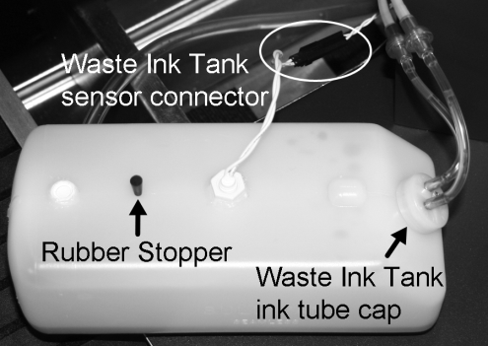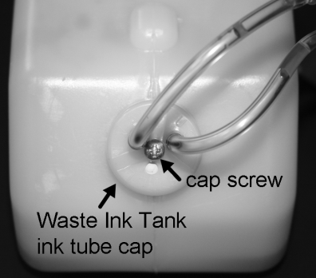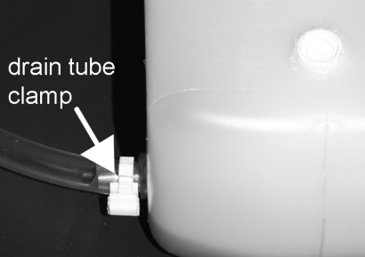

Figure 7.10b: Waste Ink Tank
- If you are operating the printer with white ink, clean the Waste Ink Tank every 6 months or replace it once a year. The white waste ink will settle, and reduce the Waste Ink Tank’s capacity. To replace or clean the Waste Ink Tank, follow the procedure below, referencing Figure 7.10b.

  - Drain the Waste Ink Tank, then lift the Waste Ink Tank up and out of the space it is seated in. The tank is secured with Velcro to the floor of the printer, so a bit of force will be needed to separate the Velcro.
  - Locate the Waste Ink Sensor (located in the middle of the top of the tank) and follow its signal cable up until you find the black sensor connector. Disconnect the sensor connector.
  - Locate the Waste Ink Tank ink tube cap (located at the top front side of the tank). Using a small screwdriver, loosen the cap screw and then lift the cap off of the tank.
  - Locate the drain tube (located on the side of the tank). Release the drain tube clamp and remove the drain tube from the tank. The Waste Ink Tank should now be completely disconnected from the printer.
  - Rinse out the tank with warm water. The settled white ink should rinse completely out.
  - Once the Waste Ink Tank has been thoroughly rinsed, replace it into the printer.
    - Reconnect the drain tube to the side of the tank and secure it with the drain tube clamp.
    - Reconnect the Waste Ink Tank ink tube cap and tighten down the cap screw.
    - Reconnect the Waste Ink Tank sensor connector.
  - Seat the Waste Ink Tank into the space under the Maintenance Station.

- Check the Ink Drip Foam located on the left and right hand sides regularly. Replace them as needed when it is soaked or excessive ink residue builds up. If you use a lot of white ink, you will have a rapid buildup of residues. Replace the foam as necessary so that the white ink residue build up on the left-hand foam will not touch the Print Head Nozzle Plate. If you do not have a new Ink Drip Foam to replace, you can re-use the Ink Drip Foam after washing. Dry the foam thoroughly before reinstalling it.

6. AnaJet SPRINT Utility Program

The AnaJet SPRINT Utility is a separate program to perform several less commonly used utility functions. These include: Reset Service Counter, Show Service Count, Ink Charge, Print Head Nozzle Check, and Resource Monitor. The SPRINT Utility program can be found in the AnaJet SPRINT Driver Program CD. It is recommended you copy the program to your desktop for future use. Note that this program has no installation; it will run directly from your desktop.

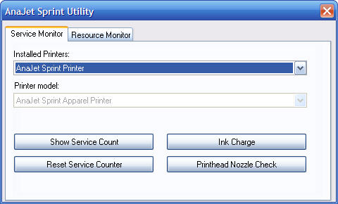

Figure 7.11: AnaJet SPRINT Utility Program Window

The SPRINT Utility consists of two tabs: Service Monitor and Resource Monitor. Make sure the AnaJet SPRINT printer is selected from the drop-down menu prior to using any of the utility functions (see Figure 7.12).

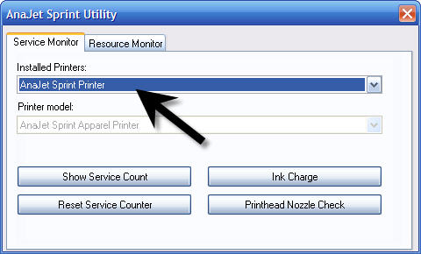

Figure 7.12: Selecting the Installed AnaJet SPRINT Printer

Utility Functions:

Show Service Count: Shows the printer’s usages point values (see Figure 7.13). When any of the maximum values are exceeded, use the Reset Service Counter Function (see Figure 7.14). This is also useful if you wish to reset the service counter prior to exceeding the maximum value.

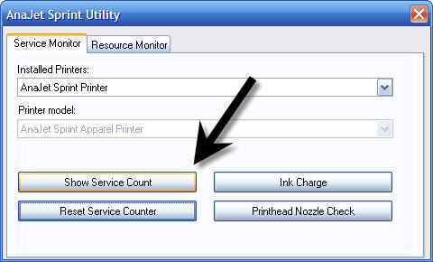

Figure 7.13: Show Service Count

Reset Service Counter: Used to reset the service count when one or both of the Service Counters have exceeded their Maximum Value. Detailed instructions on resetting the Service Counter are available in the next section.

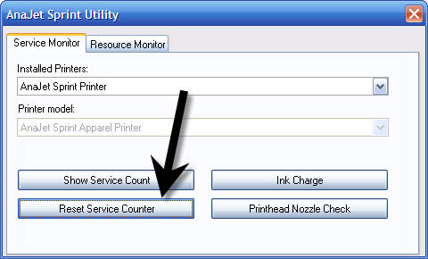

Figure 7.14: Reset Service Counter Button

Note: After a Service Counter Reset, the printer must be powered down completely. Wait one minute, then power up again. Please see the maintenance section for further explanation.

Ink Charge: An Ink Charge rapidly moves the ink through the ink delivery system. This is used to fill the ink tubes with ink, or to flush them out for cleaning or ink replacement. After clicking the Ink Charge button (see Figure 7.15), a message will appear asking you to confirm your choice (Figure 7.16). After clicking YES, the Ink Charge will begin.

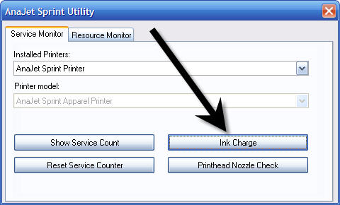

Figure 7.15: Ink Charge Button

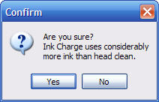

Figure 7.16: Ink Charge Confirmation Message

Print Head Nozzle Check: It prints the standard Nozzle Check Pattern (see Figure 7.17).

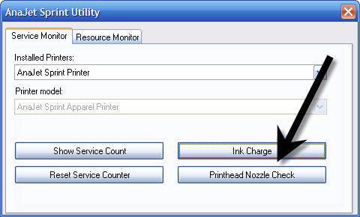

Figure 7.17: Print Head Nozzle Check Button

7. Service Count Reset

When the Service Counters reaches their maximum values, the service counters have to be reset using the SPRINT Utility Program before the printer can be used again. When it is necessary to reset the Service Counter, the printer LCD will display “ERROR: RESET SERVICE COUNT”, during the printer power up process. The WAIT and POWER LEDs will also blink, and the printer will beep. Depending on your printer usage pattern, it may be necessary to reset the Service Counter every few months.

The SPRINT Utility Program can be found on the AnaPrint program CD. You may want to copy this utility to your desktop for future use. To reset the Service Counter, follow the procedure below:

- First turn on the AnaJet SPRINT printer, including the print engine. Make sure the printer is connected to the computer.
- Run the SPRINT Utility program, and click the Service Monitor tab.
- Click the “Show Service Count” button. This will show the current values of the Service Counters.
- If either of the current values the Service Counters exceed the maximum value, the Service Counters need to be reset.
- Click the Reset Service Counter button (see Figure 7.18). After a brief moment, a message will display “Service counter reset successfully” (See Figure 7.19).

Figure 7.18: Resetting the Service Counter

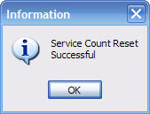

Figure 7.19: Service Count Confirmation Message

- Turn off the printer Main Power Switch, in the rear of the printer.
- Turn the printer on with the Main Power Switch first, then the Print Engine POWER key. The printer should power up normally and be ready for use if the Service Count Reset was successful.

8. Cleaning the Printer

Clean the printer a few times a year to keep the printer operating properly.

- While cleaning, be careful not touch or soil any of the gears and the Carriage Encoder Strip behind the Carriage movement space.
- Never use alcohol or thinner to clean the printer. These chemicals can damage the printer components.
- Do not use a hard or abrasive brush.
- Do not lubricate the inside of the printer. Unsuitable oil or lubricants can damage the mechanisms. Contact AnaJet or your dealer or a qualified service technician if lubrication is needed.

(1) Turn off the print engine power with the POWER key on the Control Panel. When the print engine power down sequence is completed, turn off the Main Power Switch in the rear of the printer. Open the printer top cover.

(2) Using a soft brush, clean away any dust and dirt inside the printer.

(3) Clean the Maintenance Station, Wiper Blade and around the Nozzle Plate with AnaJet Cleaning Applicators as described in section 4 of this chapter.

(4) Drain the Waste Ink Tank as needed. You will find instructions in the Waste Ink Drain Tube located in the left-side under the top cover. Replace or clean the Waste Ink Tank.

(5) Close the printer top cover.

(6) If the outer cover is dirty, clean it with a soft damp cloth with mild detergent. Make sure the water does not seep into the printer’s mechanisms.

(7) Using a damp cloth, clean the Print Table with mild detergent. Do not use ammonia based glass cleaners such as Windex as the ammonia can damage the Print Head.

9. Transporting the Printer

(1) Very Short Distance

To move the printer a very short distance, with the printer remaining at a horizontal position, follow the steps below. An example of such a move would be moving the printer within a building. If you need to move the printer a longer distance or ship it through a common carrier, follow the instructions for Short Distance or Long Distance.

- Turn off the print engine by pressing the POWER key on the Control Panel. When the print engine completes its power down sequence, switch off the printer Main Power Switch on the rear of the printer.
- Drain the Waste Ink Tank.
- Remove both the power cord and USB cable.
- The ink cartridges should remain in place. Removing ink cartridge may cause ink dry-out in the ink delivery system.
- Restrain the Print Table in place with the Table Retainer.

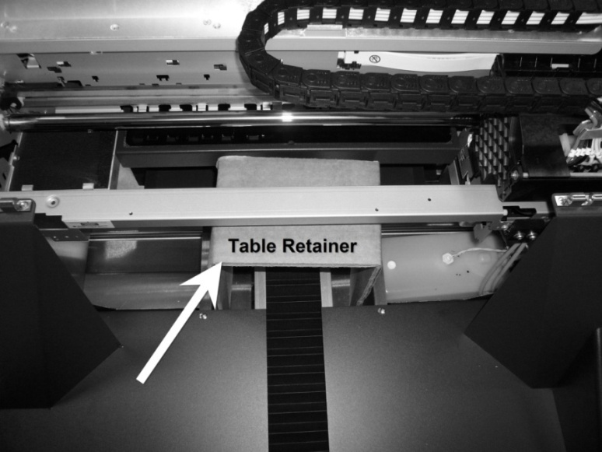

Figure 7.20: It is important to place the Table Retainer before Transport.

- Move the printer carefully (two people are required). Keep the printer horizontal.
- When it reaches the destination, make certain the printer is placed on a stable, sturdy and level table. Make sure the printer is level using a “torpedo level” as described in Chapter 1: Start Up of a New Printer, Section 4: Setting up the Printer.

- Make sure that the inks are not exposed to temperatures beyond what is recommended on the label.

(2) Short Distance

A short distance move will include moving the printer by a vehicle under your supervision, with a great deal of care being exercised during the move. The actual travel time should not take more than an hour or two. If traveling through a high temperature or very low humidity area, or if there is a large altitude change, replace the ink with Cleaning Solution and the instructions in the Long Distance section. If you are placing the printer in the printer box, you will also have to replace the ink with Cleaning Solution as the cartridges cannot remain in place for the printer to be boxed. For a long distance move or for shipping by common carriers, refer to Long Distance Move.

- Generally follow the instructions above for (1) Very Short Distance.

- Drain the Waste Ink Tank.

- Keep the ink cartridges in place. Do not leave the printer without the ink cartridges or Cleaning Solution in place. Otherwise replace ink with Cleaning Solution.

- At destination, check the printer performance. If necessary, using the AnaPrint SPRINT Utility functions, perform a Print Head Nozzle Check and clean the Print Head as needed to restore good ink flow. Leaving the printer for a long time without restoring good ink flow may cause difficulties with the ink flow later.

(3) Long Distance

- Turn on the printer Main Power Switch and the print engine POWER key.

- Replace all of the ink cartridges with Cleaning Solution cartridges.

- Open the printer cover.

- Using the Ink Pump, start replacing the ink with cleaning solution.. Notice the inks in the Ink Tubes are replaced with clear Cleaning Solution. Repeat as needed once or twice until the clear Cleaning Solution reaches the damper area and all ink lines are free of ink.
.
- Drain the Waste Ink Tank.

- Close the printer top cover.

- Turn off the print engine with the Control Panel POWER key. When the print engine completes its power down sequence, switch off the printer Main Power Switch in the rear of the printer.

- Remove all of the Cleaning Solution cartridges.

- Restrain the Print Table in place with the Table Retainer.

- Remove both the power cord and USB cable.

- Package the printer in the original shipping containers before shipping. Handle the printer with the help of a second person to avoid damage. DO NOT PLACE ANY OTHER ITEMS IN THE PRINTER BOX except the original accessory box. IF NECESSARY, USE A SECOND BOX FOR ACCESSORY ITEMS. Keep the printer level while handling and transporting.

- After transporting the printer, go through the new printer setup procedures described in Chapter 1: Start Up of a New Printer, Section 4: Setting Up the Printer. Ensure the printer is level with a “torpedo level.”

- Install the ink cartridges as soon as possible after the transporting the printer. Make certain that the right color cartridge gets installed in the right cartridge bay to avoid ink contamination.

- After replacing the USB and power cables, power up the Main Power Switch, then power on the print engine.

- Perform the Ink Charge operation once or twice using the AnaJet SPRINT Utility Program to replace the Cleaning Solution with printing inks. Make sure the ink in each of the 8 tubes reach the Damper and Print Head area by observing the Ink Tubes under the printer cover.

- Check the printer performance. If necessary, using the AnaPrint utility functions, perform a Print Head Nozzle Check. Clean the Print Head as needed to restore good ink flow. Leaving the printer for a long time without restoring good ink flow may cause difficulties later.

If you are shipping the printer through a common carrier, the printer box must be placed on a pallet. Secure the printer box onto the pallet. Ship via a trucking or air freight company with FRAGILE instructions. DO NOT USE UPS OR FEDERAL EXPRESS small package service, as they will put the printer onto conveyor belts, tumbling the printer many times. It will severely damage the printer.

Chapter 8 Troubleshooting

1. The Print Engine Does Not Turn On

During the print engine power up sequence, the Control Panel Power LED will blink and LCD will display for two or three minutes:

PLEASE WAIT
SYSTEM INITIALIZING

When the print engine properly completes the powered up sequence and the blinking Power LED becomes steady on, the Print Table will move forward to the Load Position. The LCD displays:

PRINTER READY
SEND JOB/PRINT KEY

If the Power LED continues to blink and the LCD display is hung at PLEASE WAIT SYSTEM INITIALIZING for more than 4 or 5 minutes, try one or more of these solutions.

- Turn off the Main Power Switch on the rear of the printer. Turn off your PC. Wait two minutes. Turn on the printer Main Power Switch, and wait until the LCD displays ANAJET SPRINT V x.xx PRESS POWER KEY. Push the Print Table all the way back until it stops. Then press the POWER key on the Control Panel. If the print engine turns on properly, you will see the PLEASE WAIT SYSTEM INITIALIZING display being replaced by BUSY. MOVING TABLE TO LOAD POSITION. You will also notice that the Print Table is moving forward to the Load Position. When the power up sequence is completed, you will see PRINTER READY SEND PRINT JOB. Turn on your PC.

- One or more print jobs may be in queue in the PC, confusing the print engine. Power off the printer. Then purge the print job from the computer by turning it off and on or by deleting the job from the Windows print spooler.

- Perform the Service Count Reset procedure described in Chapter 7: Maintenance and Transportation, Section 7: Service Count Reset, using the AnaJet SPRINT Utility program.

- Make sure the power outlet works and is not controlled by a wall switch or timer.

- Make sure the AC power supply voltage matches the rated voltage range, and the AC power cord is securely plugged in. If the supplied voltage and rated voltage do not match, do not plug the printer back in again. It may damage the printer.
2. The Printer Does Not Print Anything

(1) Printer not connected to PC properly

When a job is sent from the PC, the Control Panel Power LED blinks. When the job is loaded, the Print Ready LED turns on. If this does not happen, the printer did not receive the job or did not receive a job properly. The problem is likely to lie in the computer or communication.

  - Perform a Printer Port Test described in Chapter 5: Printer Software, Section 5: Using SPRINT Printer Utilities. If there is no communication between the printer and computer, proceed to the following process.

  - Make sure that AnaJet SPRINT printer is selected as the default printer on your PC and the job is sent to your SPRINT.

  - Make sure the proper USB port is selected. See Section 12: Communication and USB Related Problems of this chapter.

  - Check other issues listed in Section 12: Communication and USB Related Problems.

  - Turn off the printer and computer. Make sure the USB cable is securely plugged into both the computer and printer.

  - Make sure the cable is shielded USB cable meeting specifications.

  - Make sure the cable is directly connected to the computer without passing through other devices.

(2) AnaJet Printer Not Selected or Offline

Your AnaJet SPRINT may not have been selected as the printer to be used, and the print job may have been sent to a different device. Select AnaJet SPRINT as the default printer. Click Start/ Control Panel/ Printers and Faxes. You will see Windows Printers and Faxes dialog box shown in Figure 8.1. Right click AnaJet SPRINT, and then click Set as Default Printer.

Next make sure AnaJet SPRINT is indicated as “Ready” in the Status column. If it is indicated “Offline,” click “Use Printer Online.” You will see its status changing to “Ready.” If the AnaJet SPRINT is offline, there is also a good chance that the Port Selection for the printer is incorrect. See Section 12: Communication and USB Related Problems.

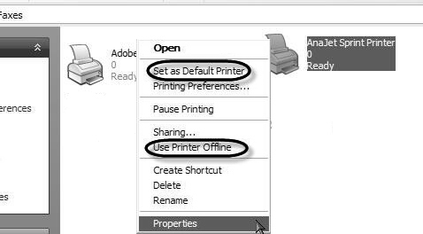

Figure 8.1: AnaJet Printer Not Selected or Offline

(3) Incorrect USB Port Selection

To select the correct USB port, see Section 12: Communication and USB Related Problems below.

(4) Reinstalling the Printer Driver

Try reinstalling the AnaPrint SPRINT printer driver program. Before reinstalling the driver, first uninstall the AnaJet printer driver by deleting the AnaJet SPRINT printer driver from Printers and Faxes utility of the Windows Control panel. Right click AnaJet SPRINT, then click Delete.

(5) Other common print problems

Other common problems may be identified by the LCD message or LED lights on the Control Panel and Ink Cartridge Bay. Try to relate one or more of the error codes listed in Chapter 3: Controls, Section 6: Error Codes.

3. Prints Are Not What You Expected

(1) Partial Print of the Design.

Make sure the Page Setup is correct in the application program. For example, for Photoshop Elements, click Files/Page Setup. Make sure that orientation is set for Portrait and the Paper Size for 12.5x16.0”, and Source is Automatically Select.

Make sure that you are using the correct AnaJet SPRINT printer driver.

Figure 8.2: Page Setup

(2) Printing in Wrong Place of the Table or Partial Print of the Design.

Make sure the Margin is set correctly in the application program. For instance, for Photoshop Elements, click File/Print Preview. In the Print Preview Window, the white rectangular area on the left represents the 12.5x16.0” Print Table, with the top being the top (closest to you) of the Print Table. The left margin on the Print Preview area is the right side edge of the Print Table if you are standing in front of the printer. Make sure the Scale to Fit Media box is unchecked. Then check and uncheck the Center Image box.

Now the design is positioned in the center of the preview area. To move the design closer to the top of the preview area (that is the top of the Print Table), enter .1 or 0 in the Position/Top box. If the Show Bounding Box is checked, you can even drag your design within the preview area with the mouse.

Figure 8.3: Print Preview in Application

(3) A Blank Page is Printed.

- Select AnaJet SPRINT printer as the default printer in Windows.

- Make certain the Margin is set correctly. (see above)

- Make certain the Page Setup is correct. (see above)

(4) Printed Color is Different from the Color on the Monitor Screen.

  - Since the monitors and printers produce colors by different methods, the printed colors will not always match on-screen colors exactly.

  - Make sure the color specifications in the application program are correct. You should use RGB color mode and specify that no ICC profiles are applied.

  - Make sure you are using AnaBright® or PolyBright inks by AnaJet. Slight change in ink shade can shift the printed image color drastically.

  - Print one of the test color pattern graphic files located in the AnaPrint SPRINT Program CD (in the Test Files folder). Adjust your monitor settings so they reasonably match what is printed.

(5) Prints are Fuzzy or there are Smears on the Images.

- If you notice that there are fine ink sprays around the printed graphics, the Print Table height is too low. Refer to Chapter 4: Printer Operation, Section 6: Adjustment of Print Table.

- It may be due to an improper Print Head Alignment. Perform Print Head Alignment using the utilities in the AnaPrint SPRINT printer driver program.

4. The Print Quality is Not Good

There are many causes of poor print quality, and the remedy depends on the
cause. Try to determine the cause by reviewing the following suggested causes.

(1) Horizontal Banding.

Figure 8.4: Example of Horizontal Banding

Try one of these solutions.

- Check the ink monitor LED indicators under the Ink Bay. Replace the cartridges if any are out of ink. If this is the case, air may have been introduced into the Ink Delivery System. Open the printer cover, and check the Ink Tubes. If any of the tubes have air in them, it will be necessary to do an Ink Charge operation after installing a new cartridge to purge the air in the system as well.

- Adjust the Print Table height to the correct level. See Chapter 4: Printer Operation, Section 6, Adjustment of Print Table.

- Run the Nozzle Check utility. If any clogged nozzle is found from the printed Nozzle Check Pattern, perform the following steps in order:
  - Perform a Head Clean Operation.
  - Print another Nozzle Check Pattern and examine for missing nozzles.
    - If the printed pattern shows no more missing nozzles, no further action is required.
    - If the printed pattern still shows missing nozzles, go to Step c.
  - Perform a second Head Clean Operation.
  - Print another Nozzle Check pattern and examine for missing nozzles.
    - If the printed pattern shows no more missing nozzles, no further action is required.
    - If the printed pattern still shows missing nozzles, go to Step e.
  - Fill the Maintenance Station with Cleaning Solution and allow the Print Head to park on the Cleaning Solution filled Maintenance Station for an hour. Then perform another Head Clean Operation.
  - Print another Nozzle Check pattern and examine for missing nozzles.
    - If the printed pattern shows no more missing nozzles, no further action is required.
    - If the printed pattern still shows missing nozzles, go to Step g.
  - Perform an Ink Charge.
  - Print another Nozzle Check Pattern and examine for missing nozzles
    - If the printed pattern shows no more missing nozzles, no further action is required.
    - If the printed pattern still shows missing nozzles, go to Step i.
  - If at this point, there are still missing nozzles, flush the entire system with Cleaning Solution and then refill the system with inks.

(2) Print Head Misalignment Problem or Banding.

If you observe vertical misalignment or banding, it may be due to Print Head misalignment. Run the Print Head Alignment function from the AnaPrint SPRINT Driver program utility page.

(3) Incorrect or Missing Colors

Try one or more of these solutions.

- Run the Nozzle Check utility and perform a Print Head Cleaning Operation as necessary.

- Make sure that you are using genuine AnaBright® or Poly Bright inks.

- Check if any of the ink cartridges are out of ink. Replace them if necessary.

- Check if all the ink cartridges are installed correctly with the right color in the right cartridge bay.

- Adjust the color settings in your graphics application program and printing program.

(4) Prints are Faint and there are Gaps.

Try one or more of the following solutions.

- Make sure that the Ink Level setting in the AnaPrint SPRINT Driver program is not too low for the media being printed on. Run the Ink Level Test Pattern to determine the optimal level of ink for the garment being printed.

- Make sure that the ink cartridges did not pass their expiration date.

- Run the Nozzle Check utility and run Print Head Cleaning Operation if needed.

- Check the Print Head Alignment utility and align the Print Head if necessary.

- Make sure the Print Table height adjustment is correct.

(5) Blurry or Smeared Prints.

Try one or more of these solutions.

- Make sure the Print Table height adjustment is correct.

- Check the Print Head Alignment utility and align the Print Head if necessary.

- The Ink Level may be too high. Run Ink Test Pattern utility and set the Ink Level correctly for the garment being printed.

- Make sure the garment being printed on is dry.

- Ink may have leaked inside the printer. Open the printer cover and wipe the inside of the printer with a soft, clean and lint free paper or cloth.

- Run the Nozzle Check utility and perform Print Head Cleaning if necessary.

5. Color Image is Printing in Black Only

- Make sure the color data setting in the graphics application program is correct.

- Make sure it is not set to be Black & White in the AnaPrint program.

- Make sure you are using AnaBright® or PolyBright inks from AnaJet.

6. Printing is too Slow

The AnaPrint SPRINT printing program is preset for optimal printing on garments. An 8.0x10.0” average image printing at an Ink Level setting of Level 2 should print in about 60 to 75 seconds from the time you press the PRINT button if you are using the Speed resolution mode (720x720dpi). If it takes longer, try one or more of the following solutions.

- Verify the resolution mode you are printing in. The three modes available are Speed, Fine, and Super Fine. The Fine and Super Fine modes increase the printing resolution, and increase the printing time.

- Do not run too many programs on your computer at the same time. Close any application programs not related to running the AnaJet printer.

- Delete unnecessary files to make room on your hard disk drive.

- Check your graphics application programs to see if there is any setting which may slow down the computer. Close graphic files you are not currently printing.

- If you are using a RIP program to run the AnaJet SPRINT printer, check the RIP program to determine if the program is generating data too slowly.

- Reboot your computer to free up resources.

- The computer may not have enough memory. If the problem persists, consider increasing the RAM in the computer.

- The computer may not have sufficient capacity to run the application and/or RIP program if you use one. If this is the case, consider upgrading your computer to one with higher speed and capacity.

7. As Soon as the PRINT Button is Pressed, the Obstruction Sensor is Triggered

Remove everything on the Print Table, and send a short print job from the computer. When the Print Ready LED lights up, press the PRINT button. If the Obstruction Sensor is triggered immediately, the Obstruction Sensor may be faulty or the Print Table may be set too high. Try one or more of the following solutions.

- Adjust the Print Table height low enough so that it will not trigger the Obstruction Sensor improperly. See Chapter 4: Printer Operation, Section 6: Adjustment of Print Table.

- Adjust the Obstruction Sensor laser so that the laser will beam directly into the laser sensor. See Section 11: Obstruction Sensor Laser Adjustment in this chapter.

- Disable the Obstruction Sensor using the * Menu (Star Menu), and contact AnaJet Technical Support. Disabling the Obstruction Sensor will allow you to use the printer until the sensor problem is resolved.

8. Print Table Does Not Travel All the Way to the Front or Rear

Try to pull the Print Table by hand all the way to the front (Load Position) and push it all the way to the rear (Home Position). Pull and push firmly but do not force it. Push and pull several times until the table moves smoothly for the entire span of its travel. The problem will most likely be resolved by this action. If lubrication is needed, do not attempt to lubricate it without the assistance of AnaJet Technical Support or your dealer.

9. Broken LCD Display Characters or Garbled Characters

It may be due to static in the room the printer is operating in. Try one or more of the following solutions.

- Turn off the printer completely (first the print engine, then the Main Power Switch). Spray anti-static spray in the area the printer is located. If the printer table is located on carpeted area, spray on the carpet. Then turn on the printer.

- Check the power outlet to make sure the wiring is correct. A complete check of the shop wiring by a licensed electrician is recommended. But a temporary quick check can be made using a simple wiring tester like the one illustrated below. Make sure the ground wire is correctly installed. If incorrect, the wiring must be corrected before turning on the power again to avoid damages to the printer.

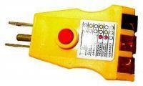

Figure 8.5: Electrical Wiring Tester

- If the humidity is too low, the static problem may increase. Install a humidifier to increase the humidity. Adequate humidity is also necessary to prevent the Print Head Nozzles from drying up.

- Make sure the chassis of the printer is grounded correctly. If necessary, reinforce the chassis grounding.

10. The Print Head Nozzles Get Clogged Too Often

The AnaJet SPRINT printer, with its Closed-Loop Ink Delivery System and sealed ink cartridges, should operate without excessive nozzle clogging. But occasional nozzle clogs are inevitable with any inkjet apparel printer. Depending on the environment and pattern of printer usage, it will be necessary to perform occasional Print Head cleaning, more frequently if white ink cartridges are installed.

Under optimal conditions, the printer can retain perfect Nozzle Test Patterns even if the printer is not used for several days. It is, however, recommended that the printer be used at least several times a week for optimal nozzle maintenance. It is also recommended that the print engine be kept on at all times and the Auto Print Head Maintenance be enabled and set to every 12 hours. With this setting, the printer will auto maintain itself to keep the nozzles clear at all times.

If your printer nozzle clogging is excessive, try one or more of the following solutions.

- Make sure you only use AnaBright® or PolyBright inks.

- Verify that the humidity around the printer is above 45% Minimum. Low humidity dries out the inks and can cause nozzle clogging.

- Keep the Maintenance Station, Wiper Blade and Print Head Nozzle Plate clean by regular cleaning. See Chapter 7: Maintenance and Transportation, Section 4: Cleaning Maintenance Station and Nozzle Plate.

- The white ink used for dark garment printing tends to settle. If the nozzle clogging problem is mainly for white inks, it may be due to ink settling. You must gently shake the installed white ink cartridges once or twice a week. You need to pull the white ink cartridges out of the cartridge bay, shake them gently and reinsert them. Make sure that the ink does not spill while shaking by wrapping the cartridges in a paper towel.

- Check and make sure the inks, particularly white ink, did not expire. Expired inks agglomerate and clog the Ink Delivery System and nozzles. The ink expiration date is indicated on the cartridge. The colored inks expire in one year after manufacturing, and white ink in six months.

- For unused white ink cartridges in storage, try to turn them over once every few days until they are used. You can also gently shake the unopened white ink cartridges. This will prevent the white ink components from settling.

11. Obstruction Sensor Laser Adjustment

If the Obstruction Sensor Laser and its Sensor become misaligned, follow the procedure below to correct it.

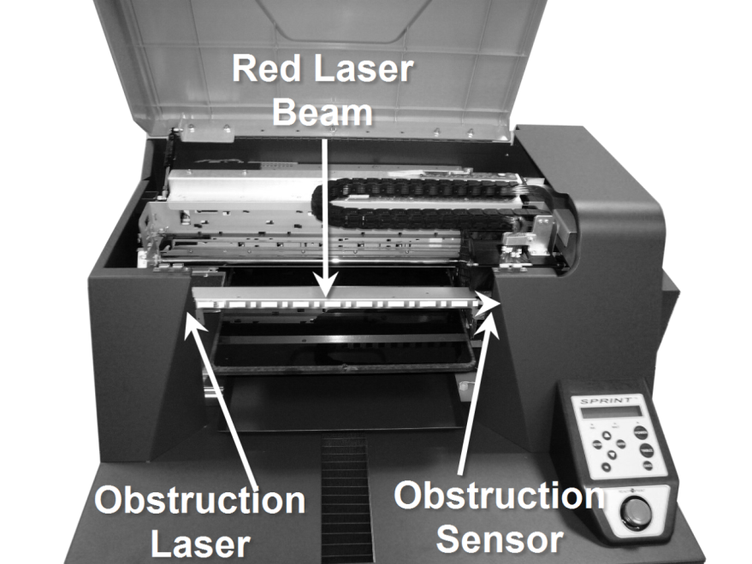

Figure 8.6: Obstruction Laser and Sensor

(1) Adjust the Print Table. (See Chapter 4: Printer Operation, Section 6,
Adjustment of Print Table.)
(2) Turn on the laser from the Obstruction Sensor Setting in the Star (*) Menu.
(3) Place the Gauge Block on the Print Table at the left edge of the Print Table with
the alignment line parallel to and closest to the Print Table.
(4) Adjust the laser vertically until the laser dot is on the alignment line.
(5) Move the Gauge Block to the right side of the Print Table.
(6) Adjust the laser angle until the laser dot is on the alignment line.
(7) Recheck the alignment at the left side.
(8) Remove the Gauge Block.
(9) Adjust the sensor block vertically until the laser dot is even with the centerline of
the sensor opening.
(10) Adjust the 2 set screws in the laser mounting block to align the laser dot in the horizontal plane with the center of the sensor opening. This may require loosening the laser mounting block screws slightly to allow movement.

12. Communication and USB Related Problems

(1) Operating System

Make sure that your computer is a PC, running on Windows XP or VISTA 32-bit operating system. The AnaJet SPRINT printer does not support Apple computers, nor does it support VISTA 64-bit systems.

(2) Support of USB 2.0

Your USB must support USB 2.0 protocol. Older computers may not support USB 2.0. You may not be able to run the AnaJet USB SPRINT printer driver on a computer which is not equipped with a USB port or which is upgraded from Windows 95, 98 or 2000. For details about your computer, contact a computer consultant.

(3) Printer Settings

Make sure that AnaJet SPRINT appears in Windows Printers and Faxes list, ready to be used and selected as the Default Printer. Click Start/Control/Printers and Faxes, then look for AnaJet SPRINT Printer.

Figure 8.7: Printer Settings

If AnaJet SPRINT does not appear under the Name column, your AnaPrint print program and driver are not installed or not installed properly. You must install the AnaPrint program. Notice the Status of AnaJet SPRINT is Ready. If it is shown to be Offline, your printer might not be turned on, the USB cable is not installed correctly or the printer is put into Offline status. Correct these problems.

To put the printer online or Ready, right click while the cursor is pointing at AnaJet SPRINT. When the menu opens (see Figure 8.7), left click Use Printer Online. Notice AnaJet SPRINT status changes to Ready.

While you are at it, you may also make sure that AnaJet SPRINT is chosen as the Default Printer. Just click “Set as Default Printer”. If AnaJet SPRINT is already selected as the default printer, you will not see the Set as Default Printer option in the menu.

(4) USB Port Selection

Incorrect USB Port specification is one of the most common problems. Perform a Printer Port Test described in Chapter 5: Printer Software, Section 5: Using SPRINT Printer Utilities. If there is no communication between the printer and computer, it is likely that the printer is assigned to the wrong USB COMM port.

To assign the proper USB port to AnaJet SPRINT printer, click Start / Control Panel / Printers & Faxes. From the Printers & Faxes dialog box, double click AnaJet SPRINT. When the AnaJet SPRINT Properties dialog box opens, click Ports tab (see Figure 8.8). Check the proper USB port if you know the correct USB port (in this illustration, it is USB006), then OK. Proceed to perform the Printer Port Test in the AnaPrint Utilities window to confirm. If you do not know which port is assigned to AnaJet SPRINT, you may have to try each of the USB ports listed in the Ports tab dialog box until you make the proper connection.

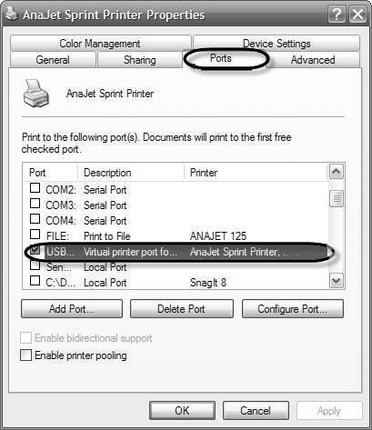

Figure 8.8: USB Port Selection

(5) Printer Port Test

Once all of the above problems are resolved, perform a Printer Port Test in the
AnaPrint utilities window to make sure the computer and AnaJet SPRINT are
communicating properly. See Chapter 5, Section 5, Using Printer Utilities.

13. Cable Problems

If solutions in USB Related Problems do not resolve the communication problem, it may be related to the USB cable. Try one or more of these solutions.

- Use the recommended shielded USB cable no longer than 2 meters.

- If you use a USB hub, connect the printer to the first tier of the hub, or connect the printer to the computer’s USB port directly.

14. How to Get Additional Help

AnaJet provides technical support for the installation, setup, operation and trouble shooting of AnaJet Printers, AnaPrint printing software and AnaBright® and PolyBright™ inks while they are under warranty free of charge. AnaJet system owners should register as soon as possible to avoid delays in getting support. For Warranty Registration, go to www.anajet.com and click Registration. Upon registration, you will receive an email informing of your Customer Number, User Name [your registered email address] and Password. Do not share your Password with anyone outside your company as your security can be compromised.

Once registered, you can log into the AnaJet Tech Support pages to access documents and videos and download updated program files, etc. You can also email technical support questions to tech1@anajet.com. Please be sure to include your name, business name, telephone number and Customer Number if you know it. We will not respond to any email, without proper identification of the sender. If you have already been assigned a case number, include it in the message as well. Please be to the point and concise in your question. You can also call AnaJet Technical Support at 714-662-3200 during the hours of 8:00AM to 5:00PM Pacific Time, Monday through Friday

Those who made warranty registration can also sign-up for the AnaJet Users Forum, accessible from AnaJet website. At the forum, you can interact with other users and AnaJet staffers to share information. It is a wonderful resource if you have questions about your printer or garment decoration business.

We are not able to provide support for problems relating to your computer, Windows operating system, non-AnaJet software. Please direct support issues for these products to the appropriate makers and vendors.

Appendix 1

AnaJet SPRINT Consumables Recommended Stock Level
Description | AnaJet  Part Number | Recommended Stock Level
AnaBright® Ink Cartridge (Yellow) | ABA-YL2 | 2 or two week supply
AnaBright® Ink Cartridge (Magenta) | ABA-MG2 | 2 or two week supply
AnaBright® Ink Cartridge (Cyan) | ABA-CY2 | 2 or two week supply
AnaBright® Ink Cartridge (Black) | ABA-BK2 | 2 or two week supply
AnaBright® Ink Cartridge (White) | ABA-WH2 | 8 or two week supply
AnaBright® Cleaning Solution Cartridge | CF-GW1 | 8 (no less than half full)
AnaBright® Pretreatment Liquid  (64 oz bottle) | ABA-PRE1 | 2 or two week supply
PolyBright™ Ink Cartridge (Yellow) | PBI-YL1 | 2 or two week supply
PolyBright™ Ink Cartridge (Magenta) | PBI-MG1 | 2 or two week supply
PolyBright™ Ink Cartridge (Cyan) | PBI-CY1 | 2 or two week supply
PolyBright™ Ink Cartridge (Black) | PBI-BK1 | 2 or two week supply
PolyBright™ Primer (64 oz bottle) | PBI-PM1 | 2 or two week supply
Maintenance Station  Cleaning Solution (4 oz bottle) | CF-FT125 | 1 bottle (unused)
Cleaning Applicator (25 Wide tip) | CA-WD1 | 1 bag (unused)  Any type will do, depending on user preference.
Cleaning Applicator (25 Narrow tip) | CA-NR1
Cleaning Applicator (25 Wide tip and 25 Narrow tip mixed bag) | CA-MX1
Dampers | 100540 | 4 (unused)
Print Head (Gen 2) | 101173 | Do not keep in stock.
Drip Pan Foam (left side) | 100298 | 1 (can be reused)
Drip Pan Foam (right side) | 101113 | 1 (can be reused)
Maintenance Station Wiper Blade | 100562 | 1
* Ink Cartridges specify the expiration or manufacturing date. Use before expiry date.
*Colored ink useful life: one year after the indicated manufacturing date.
*White ink useful like: six months after the indicated manufacturing date.
*Cleaning solution: three years after the indicated manufacturing date.

AnaJet SPRINT Recommended Non-Consumable Items

Description | AnaJet Part Number | Remarks
Print Table (regular size)  12.5” x 16.00” | PT-1250R | Replacement Print Table (same as original unit)
Print Table (Hooped)  12.5” x 16.00” | PT-1250RH | Replacement Print Table
Youth Size Print Table  8.5” x 12.00” | PT-850Y | For youth shirt printing.
Youth Print Table (Hooped)  8.5” x 12.00” | PT-850YH | For youth shirt printing.
Long Print Table  8.5” x 16.00” | PT-850L | Long print table
Gauge Block | GBLK1 | For Print Table height adjustment.

Appendix 2

WHITE INK SYSTEM MAINTENANCE CHECK LIST

INITIAL WHEN MAINTENANCE IS PERFORMED.
DATE | NOZZLE CHECK | HEAD CLEAN | SHAKE WHITE INK | CLEAN  MAINT. STAT. | CLEANING SOLUTION CHARGE | CHECK LEFT & RIGHT PAN | CHECK WASTE INK | OTHER MISC.
 | DAILY | AS NEEDED | WEEKLY | WEEKLY | MONTHLY | MONTHLY | MONTHLY

Appendix 3
Updating Printer Firmware

The printer firmware is computer software programmed into a chip (integrated circuit or IC) in the printer controller circuit board. When the firmware improves, sometimes it is desirable to update it. In the rare event it is necessary to update the firmware, this step by step guide will be helpful.

For updating the firmware, you need the following three items.
- AVRS Programmer, Programmer Cable and USB Cable
- AVRS Studio Application Program provided with the AVRS Programmer
(software necessary to run the Programmer)
- New AnaJet SPRINT firmware

A. Installing the AVRS Studio Application Program in a PC:

- The Application Program should be installed in a PC (the computer you normally use for running the AnaJet printer, although you can use another PC) before plugging in the Programmer Cable.

- Insert the AVR Studio Application Program disc into the CD drive.

- Follow the onscreen instructions of the InstallShield Wizard.

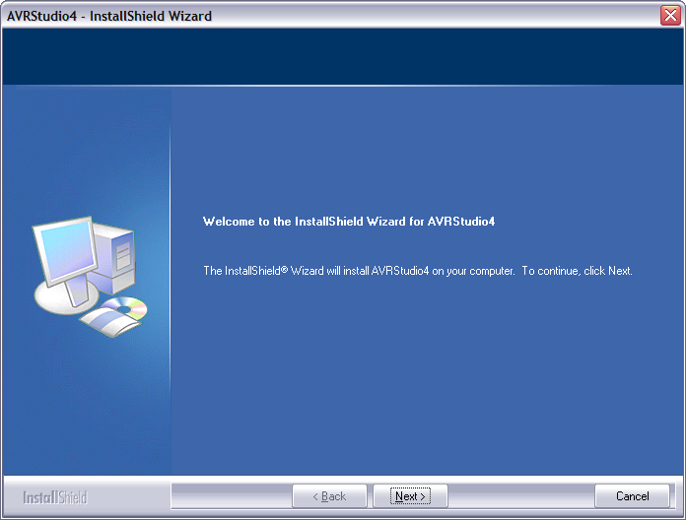

Figure A3.1: InstallShield Wizard

  - On the Select Features Window, make sure “Install/Upgrade USB Driver” is checked as shown in the screen shot in Figure A3.2 below.

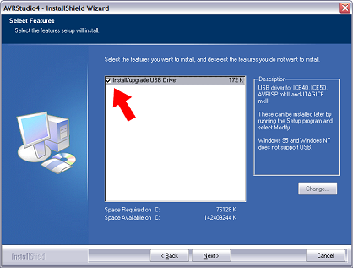
Figure A3.2: Select Features

- When the InstallShield Wizard is complete, the application is ready to use.

B. Hooking up the AVRS Programmer:

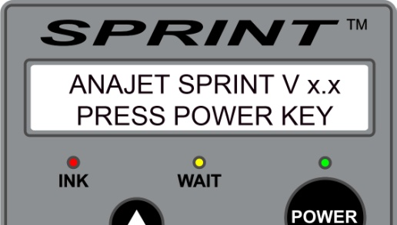

Figure A3.3: Printer Control Panel

- Turn on the Main Power Switch of the AnaJet printer, but make certain the print engine is not powered. If the printer is powered, press the POWER key on the printer Control Panel to power down the print engine. When the power down sequence is completed, the green POWER LED will turn off, and the Control Panel LCD will display:
ANAJET SPRINT V x.x
PRESS POWER KEY

- Disconnect the USB cable from the printer and plug it into the AVRS Programmer USB port.

  - A green light close to the USB port on the programmer will light up.
  - The computer will display that new hardware has been found. Click NEXT through that Wizard to establish communication between the Programmer and your PC.

- Using the Programmer special cable, connect the AVRS Programmer with the AnaJet Program Port on the back of the printer. Make certain the “red dot” on the special cable connector is facing up.

  - When the Programmer is plugged into the printer correctly, the LED near the programmer cable will light green. If not plugged in properly, the LED will light red.

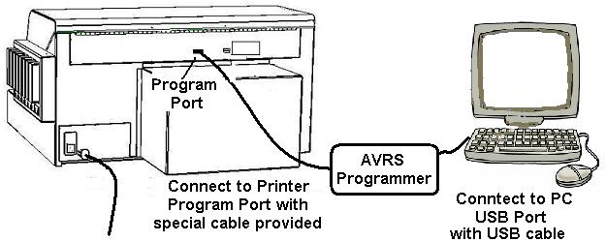

Figure A3.4: AVRS Programmer Connection

C. Updating the Firmware

- Run the installed AVR Studio program:
Start / All Programs / Atmel AVR Tools / AVR Studio 4.
- Click on the AVR button.

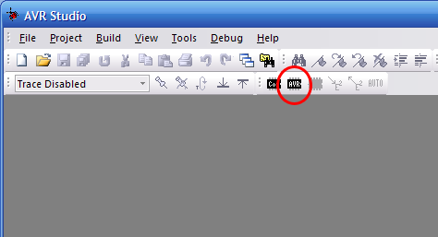
Figure A3.5: AVR Studio

- When using the program for the first time, the ‘Select AVR Programmer’ dialog window in Figure A3.6 will pop up. The Programmer type will need to be selected: For Platform, choose AVRISP mkII, for Port choose USB (only choice available). Then click Connect.

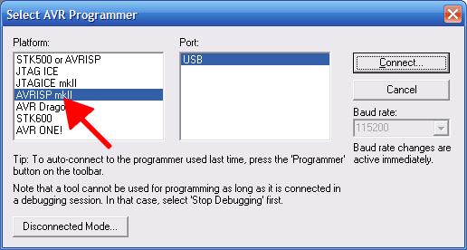

Figure A3.6: Select AVR Programmer

4. In the AVRISP mkII programming window (see Figure A3.7) do the following:

a. Under Device, choose Atmega128, under Programming mode choose ISP mode. Make sure Erase Device… and Verify Device… are checked.

b. Under Flash, load the latest firmware. To load the Input HEX File (the new firmware), click on the […] button and browse your computer directories to where the firmware is located. (Often this file will be located on a CD from AnaJet.)

c. Click the Program button to program the new firmware onto the printer.

d. Pending a successful firmware update, after about 10 seconds the LCD on the printer will display the new firmware number.

e. Close the AVR Studio program by clicking x button at the top of the AVRISP window. Unplug the programmer from the printer. Reconnect the USB Cable to your printer USB port.

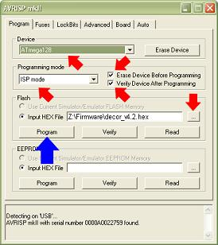

Figure A3.7: AVRISP Window

Now you are ready to run the printer with the new firmware.

Appendix 4

EKPrint Studio

for

AnaJet® SPRINT™

RIP Program for

Dark Garment Printing

User Manual

Ver. 1.1

Copyright © 2014 AnaJet LLC All rights reserved.

AnaJet® is a registered trademark and SPRINT™ is a trademark of AnaJet, LLC

Table of Contents

1. Installation 3

2. Obtaining a Software License 5

3. Opening a File 7

4. Scaling and Positioning an Image 7

5. Print Setup Pane 8

6. Textile Color Button 10

7. White Ink Underbase 10

8. Ink Setting Button 15

9. Configuration Menu 18

10. Save Options 21

11. Calling EK Direct from Other Apps 21

12. Basic How To & Recap 22

EKprint Studio for AnaJet SPRINT is designed so that user help can be obtained from the program itself.

Click the Help button at the lower left corner of the main window, or on the menu bar, click Help > Content.

This abbreviated User Manual is for a general overview and as a quick start guide.

- Installation

Close all programs in Windows and begin at the Microsoft Windows desktop.

Insert the EKPrint Studio for SPRINT installation CD into your CD-ROM drive. The EKPrint Studio for SPRINT startup window will appear.

Note: If the startup window does not automatically appear, you will need to start the setup manually as follows.

Select Start->Run from the Microsoft Windows desktop and click Browse.

Navigate to the CD/DVD drive that the EKPrint Studio for SPRINT installation CD is in.

Double-click the Setup.exe file.

Follow the on-screen instructions.

For Windows Vista users, please follow these additional steps before running EKPrint Studio for SPRINT for the first time.

a) Open the directory that EKPrint Studio for SPRINT is installed within. Most likely this will be c:\Program Files\EUKON DIGITAL\EKPrint Studio (AnaJet Sprint).

b) Right Click on EKPrint Studio (AnaJet Sprint).exe (see Figure 1a).

Figure 1a: EKPrint Studio (AnaJet Sprint) Icon

c) Select Properties.

d) Click the compatibility tab and check the run as administrator checkbox.

EKPrint Studio for SPRINT also comes with the optional ability to be called directly from a graphics application program, such as Photoshop or CorelDraw. For this function to work, the EKRIP Driver will have to be installed as well. The following instructions apply to both Windows XP and Vista.

(1) To install the EKRIP Driver, you will first need to know what USB port your SPRINT printer is connected on. To find out, go to the Windows Control Panel and double click on the Printers and Faxes icon.

(2) Right click on the AnaJet SPRINT Printer and choose Properties.

(3) Click on the Ports tab.

(4) Expand the Port column’s width so that it is wide enough to show the entire list of all the ports. Look for the port that the AnaJet SPRINT Printer is connected to and remember that port. This window can now be closed.

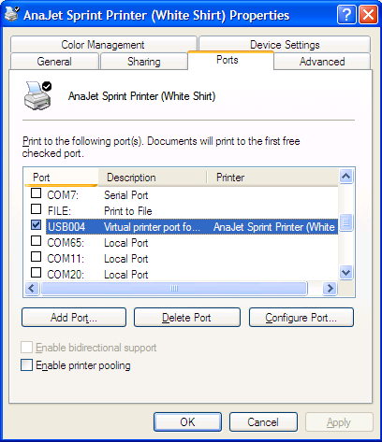

Figure 1b: AnaJet SPRINT Printer Properties

To install the EKPrint RIP driver in the Printers and Faxes folder, right click on a blank area on the screen and choose Add Printer to bring up the Add Printer Wizard. Follow the wizard.

When prompted to select between a Local printer or Network printer, choose Local printer. For Windows XP, be sure to uncheck “Automatically detect and install my Plug and Play printer” (see Figure 1c).

When prompted to select which port the printer is on, select the printer port that was discovered in step 4 above.

When prompted to Install Printer Software, click on the Have Disk button (see Figure 1d).

Then click on Browse.

Next click on browse to the EKPrint RIP driver folder in the EKPrint CD.

Select the ekcolor.inf file.

Follow through the rest of the Wizard.

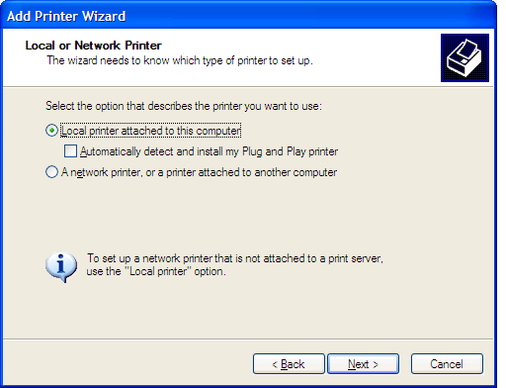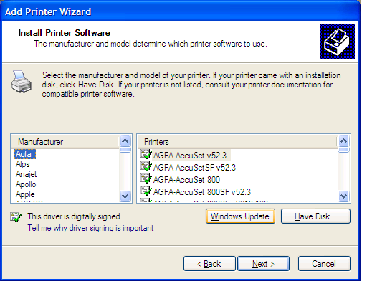

Figure 1c: Selecting Local Printer Figure 1d: Install Printer Software

Obtaining a Software License

A valid software license file is needed to run the EKPrint Studio for SPRINT program. Without a valid license file, EKPrint Studio for SPRINT will run under evaluation mode for 30 days. After the 30 day evaluation period, the print capability of EKPrint Studio for SPRINT will be disabled. Please note that EKPrint Studio for SPRINT is a completely separate program from previous EKPrint Studios for the AnaJet FP-125 printer. It will require its own license even if you have a previous version of EKPrint installed and licensed. The following steps show you how to obtain a license file.

For PCs that are connected to the Internet:

After installation of the EKPrint Studio for SPRINT software and the AnaPrint SPRINT driver program, start the EKPrint Studio for SPRINT program.

Click on the OK button to skip the license reminder.

Then click on the dialog menu Help > Product Activation (see Figure 2a).

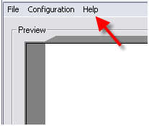

Figure 2a: EKPrint Studio Help

Click on the OK button; fill in the information in the License Request dialog. Note: The product serial number is printed on the back cover of the installation CD.

Click the Request button.

After the licensing process is finished, exit the EKPrint Studio for SPRINT program and then restart the program.

For PCs that are not connected to the Internet:

Start the EKPrint Studio for SPRINT program.

Click on Help > MAC address to get the MAC address of the PC.

On a separate computer that is connected to the internet, visit www.eukondigital.com or send an email to license@eukondigital.com to file a license request with following information.

a. Name

b. Company Name

c. EKPrint Studio Serial Number (Located on the back cover of the EKPrint Studio for SPRINT installation CD.)

d. Phone Number

e. Email Address (Please use a valid email address as the license file will be emailed to this address.)

f. Network Card Information (The MAC address information you collected in step 2 above.)

A license file (license.txt) will be generated and emailed back to you.

After receiving the license file, start the EKPrint Studio for SPRINT program.

Click on Help > Product Activation.

Select Install license file.

Browse to the license.txt file you have received and click on the OK button.

Restart the EKPrint Studio for SPRINT program.

- Opening a File

- Supported File Types
EKPrint Studio for SPRINT supports the following file types: TIFF (.tif), GIF (.gif), JPEG (.jpg), PNG (.png), EXIF (.exif) and BITMAP (.bmp) [Note that TIFF or PNG files are most commonly used for dark garments, because TIFF and PNG files support transparencies.]

- To open a file, click the open button and browse to the file you would like to open. Alternatively, you can simply drag files into the preview screen.

- Scaling and Positioning an Image
All adjustments to file positions are shown in the preview window (see Figure 4a). This preview window represents the Print Table. The lip shown at the top represents the top triangle of the Print Table.

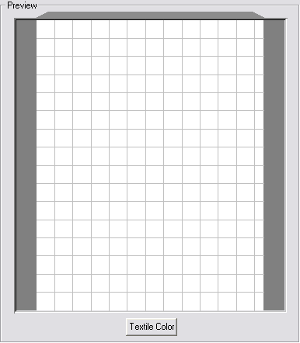

Figure 4a: Preview Window

A. Scaling a Print
A print can be scaled in three ways (see Figure 4b):

- Using the “Scale” control changes the size of a print as a percentage of the digital image size.
- Using the height or width controls sets a specific height or width. [Note that the ratio is fixed. If a user adjusts one value the alternate value will be automatically adjusted. Also note that the RIP does not distinguish between printable and transparent areas when listing an image’s scale or positioning.]
- Clicking and dragging from the corner of an image in the preview screen will increase or decrease the size of a print.
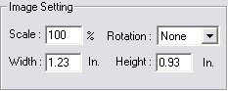
Figure 4b: Scaling a Print Settings
B. Positioning an Image
Positioning has several options:

- An image can be dragged around the preview screen. [Note that if snap to grid is enabled, it will influence this behavior. Snap to grid is detailed in Section 9: Configuration Menu.]
- A print can be positioned to specific measurements by entering values into the Offset controls. The Center Adjusted checkbox will automatically be enabled. This checkbox returns the print to the center of the preview window and Print Table. Most t-shirts look better when the image is positioned closer to the top of the preview window rather than at the center. [Note that the offset can be entered in two options: Center Based and Left Top Based. This option is described in more detail in the Axis Origin in Section 9 of this manual.]
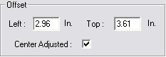
Figure 4c: Positioning an Image

- Print Setup Pane

- Table Size: This refers to the size of the Print Table installed in the printer. The Table Size also selects portrait or landscape printing. The Table Sizes are marked with a (P) or (L) respectively. Portrait will position prints vertically, and landscape will position prints horizontally.
- Ink Drop Size: This refers to the size of the Ink Drop being used. A larger drop will give more ink saturation, while smaller drop will give more detail.
- Ink Level: This refers to the ink volume for a given Ink Drop Size. This control works together with Ink Drop Size to control the amount of ink saturation. The higher the Ink Level, the more the ink saturation that will be seen in a garment.
- Color Mode: Different color modes change both color profiles and dithering routines. Dithering routines are the patterns in which ink drops are applied to garments. The EKPrint Studio for SPRINT program’s internal color profiles control the shade, tint, hue and saturation of printed colors. [Note that color modes with stochastic dithering routines will have smoother gradients, and better simulation of photographs. Individual ink drops may appear more distinct when printed using stochastic dithering routines. Color modes using regular dithering routines will provide excellent solid colors and very small distances between individual ink drops that cause colors to appear more homogenous.]
- Vivid: This mode generates the most vibrant color values to give high color intensity. This is not the most accurate color, but it may appeal to many garment printing applications with high color vibrancy. (Stochastic Dithering Routine)
- Standard: This mode offers more accurate color, but less intensity than the Vivid mode. (Stochastic Dithering Routine)
- Photo: This mode gives high quality flesh tones. This mode uses a dot size that is even lighter than the Light Ink Drop Size. As such, Ink Drop Size controls are disabled for this color mode. It is recommended for printing photographic images or highly detailed graphics. (Stochastic Dithering Routine)
- Black/White: This mode prints only from the K black ink channel and redefines colors into grayscale. [Note that K black may not seem as intense as the processed black of the Vivid mode.] (Stochastic Dithering Routine)
- Text1Neutral: This mode offers the most accurate colors. This mode also uses a dot size that is even lighter than the Light Ink Drop Size. As such, Ink Drop Size controls are disabled for this color mode. (Regular Dithering)
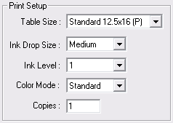
Figure 5a: Print Setup Pane

- Textile Color Button

Located below the preview pane, the textile color button allows a user to preview differently colored backgrounds. You can select a default color, or you can select a custom color. This feature only affects the preview screen; printing will not be changed in any way.

Custom colors can be defined by RGB value, Hue, Saturation and Luminosity controls, or by the Graphical Color Finder and Luminosity bar.
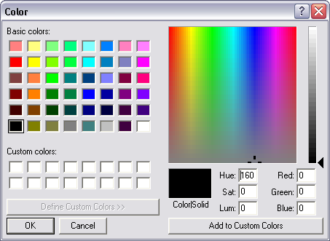
Figure 6a: Textile Color Selector

- White Ink Underbase

This feature allows for printing on dark garments and is not necessary for light garments. Checking Enabled will make the printer print a white ink underbase before printing CMYK colored inks (see Figure 7a). Checking Preview will change the preview area to display what the white underbase will look like. If the Settings button is pressed, the Black Textile Print Settings window will appear (see Figure 7b). From this window you will be able to control all the settings for white ink.

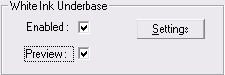

Figure 7a: White Ink Underbase

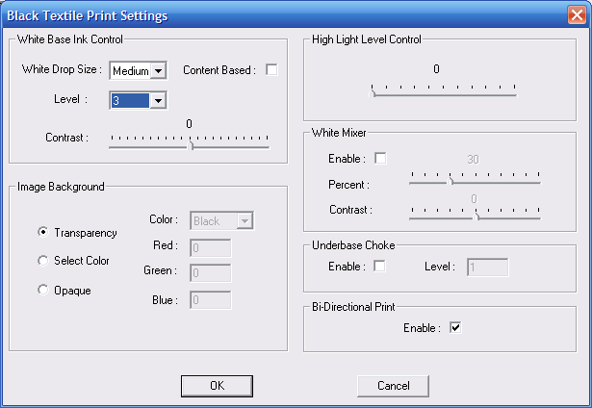

Figure 7b: Black Textile Print Settings

- White Base Ink Control: This pane is the primary control for the white underbase. These controls are independent of the color ink controls.
- White Drop Size: This adjustment controls the size of the Ink Drop for the white underbase. The options for White Drop Size are: Heavy, Medium or Light. For most prints, Heavy or Medium would be selected, unless a distressed or specialty look is trying to be achieved.
- Level: This adjustment controls the number of passes the Print Head will do on the same line before advancing the Print Table during the printing of the white underbase.
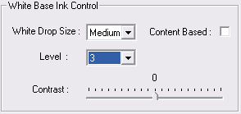

Figure 7c: White Base Ink Control

- Contrast: This adjustment controls the level of fade in transparent gradients. The minimum value is -100 and the maximum value is +100. Changes made here are reflected in the white underbase preview. [Note the contrast function changes when the Content Based checkbox is checked.]
- Content Based:
- If unchecked, an even underbase will be printed under all colors.
- If checked, the underbase will be printed based on the color content of the graphic (more white ink under lighter colors and less white ink under darker colors).
- Contrast: When Content Based is selected, this controls the amount of variance between the areas that will receive the most amount of ink and the areas that will receive the least amount of ink in the same underbase. The higher the value, the less amount of ink the dark areas will receive and the more ink the light areas will receive proportionally. The lower the value, the more even the amount of white ink the dark and light areas will receive. [Note the contrast function changes when the Content Based checkbox is unchecked.]
Note: Enabling/Disabling Content Based and adjusting the Contrast will affect the white underbase preview’s appearance.
High Light Level Control: This controls the amount of white high light. If used, this causes the printer to print more white during the color printing, but exclusively in white areas of the design. [Note that white high light is influenced by the Ink Drop Size and Ink Level of color settings, rather than the underbase settings.]
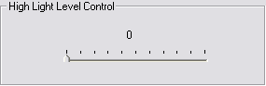
Figure 7d: High Light Level Control
- White Mixer: This control allows you to mix white ink into the colored inks during printing. This will lighten the shade of the colors. I.E. a red will look more pink and a blue will look more light blue.
The Contrast controls the variance between the dark colors that receive the least amount of White Mixer and the light colors that receive the greatest amount of White Mixer. The minimum contrast level is 0.1 and the maximum contrast level is 1.5. The overall adjustment for the amount of White Mixer is controlled by the corresponding slider bar. The minimum value is 0 and the maximum value is 100. [Note that this feature is designed to compensate for the optical effects of dark backgrounds.]
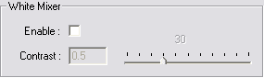
Figure 7e: White Mixer
- Underbase Choke: This control compensates for swelling of garments due to wet ink. The wet white underbase can cause garments to swell. This swelling can result in the underbase spreading out wider than the top color layer. Underbase choke reduces the underbase from the edges by the number of pixels entered into the field. The possible values are integers from 1 to 40. The higher the value the farther underbase will be reduced from the edges.
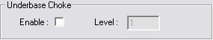
Figure 7f: Underbase Choke
- Bi-Directional Print: This enables bi-directional printing of white underbase. Bi-directional printing means that the printer will print in both directions: left to right and right to left. [Note that some users use uni-directional printing to slow down the printing process to allow extra time for the drying of the underbase before the printing of CMYK ink.]
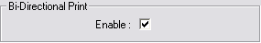
Figure 7g: Bi-Directional Print
- Image Background: This control allows users to define areas of the file that, when printed, remain the color of the garment. This means that these areas within the image file will receive no ink during the dark shirt printing process.
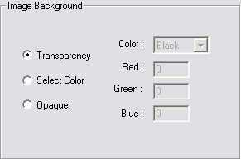
Figure 7h: Image Background
- Transparency: When selected, the transparent areas of an image will not print. This is the preferred method for preparing images. [Note that your file type must support transparencies. See Section 3 of this manual for compatible file types.]
- Select Color: When selected, this allows a user to select a specific RGB value to not be printed. [Note that if this is used with a file that has transparent areas, those areas will be replaced with black.]
- Opaque: When selected, the entire rectangular area of the file will receive ink. For example, the entire background color of the image will be printed. [Note that this is the default setting for file types that do not support transparencies.]

- Ink Setting Button
Note that the following portions of the manual are no longer referring to the white ink settings.
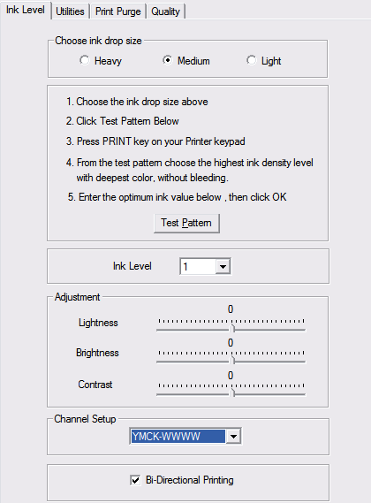

Figure 8a: Ink Level Settings

From the ink settings button located at the bottom of the main EKPrint Studio for SPRINT window, you gain access to four tabs: Ink Level, Utilities, Print Nozzle by Print Head, and Quality.

- Ink Level Tab
- Choose ink drop size: This allows you to select the size of the average ink drop used to print the color pass (but not the white underbase). A heavier ink drop will give more coverage, and a lighter ink drop will provide more detail. The same function can be accessed through the print setup pane mentioned in Section 4 of this manual.
- Test Pattern: This will print a test pattern at the assigned Ink Drop Size at five different Ink Levels. This can help users choose the correct setting for a given type of garment. The optimal setting for light garments is the most amount of ink before images start to bleed.
- Ink Level: This controls the Ink Level with a given Ink Drop Size. [Note that the same function can be accessed through the print setup pane mentioned in Section 4 of this manual.]
- Adjustment
- Lightness: This adjusts how intense or dark the overall print will look. Adjustments to the left will darken the overall image while adjustments to the right will lighten and intensify the overall image.
- Brightness: This adjusts how light or dark the light sections of an image will print. To the left will darken and to the right will lighten. [Note that this adjustment is relative to the overall amount of ink being put onto a given textile.]
- Contrast: This adjusts how light or dark the dark sections of an image will print. To the left will darken and to the right will lighten. [Note that this adjustment is relative to the overall amount of ink being put onto a given textile.]

- Channel Setup
- YMCK-WWWW should be selected if the printer has four channels of CMYK ink and four channels of white ink.
- YMCK-YMCK should be selected if the printer has all eight channels with CMYK ink, and a user wishes to print will all 8 channels at the same time. [Note that this setting is for printing exclusively light colored garments without white ink. White Underbase options will be grayed out when selected.]
- Bi-Directional Printing: This enables bi-directional printing for the color layer. Bi-directional printing means that the printer will print in both directions: left to right and right to left.

- Utilities Tab
The utilities activated from this tab function the same as the utilities activated from the driver and are listed in the general user manual with the exception of “Auto Print Head Clean When Printer in Idle”.

- Auto Print Head Clean When Printer in Idle: This utility allows the RIP software to automatically perform Print Head cleans without user integration. [Note that the printer must be fully turned on, the computer must not be off or go to sleep and EKPrint Studio for SPRINT must remain open. Also note that this utility is not intended to be operated for more than three days; if the printer will be idle for more than three days, it is recommended that ink inside the SPRINT be replaced with Cleaning Solution.]
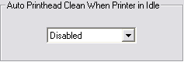

Figure 8b: Auto Print Head Clean

- Print Purge Tab
This utility prints a small amount of ink from any single channel or combination of channels for the purposes of alleviating minor flow issues. [Often users will purge from the back four channels in order to purge overnight settlement of white ink.]
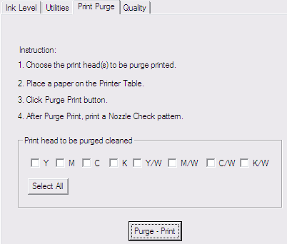
Figure 8c: Print Purge Tab

- Quality Tab
The Quality Tab allows you to choose what resolution mode the printer will print at. There are separate resolution controls for both the Image Color Layer and White Underbase. For each, there are three modes to choose from:
- Normal (720x720dpi)
- Fine (1440x720dpi)
- Super Fine (1440x1440)
- Configuration Menu

From the Configuration menu users can select Ink Setting, Printer, and System.

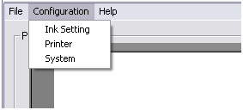

Figure 9a: Configuration Menu

- Ink Setting: This menu activates the same control pane as the Ink Setting Button described on page 11 of this manual.

- Printer: This menu allows you to select the appropriate printer to be used with EKPrint Studio for SPRINT.

- System: This menu opens the system configuration window.

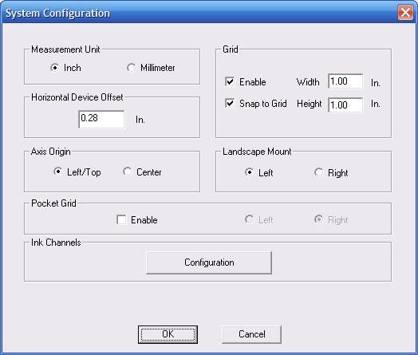

Figure 9b: System Configuration Menu

- Measurement Unit: This control allows users to switch between American and Metric measurement units.

- Horizontal Device Offset: This finely adjusts the position of all prints in relation to the Print Table left to right by adjusting the zero point. This utility is normally only used when first setting up a printer.

- Axis Origin
- Left /Top: Selecting this means that images will be offset based on the distance from the left top corner of the Print Table to the left top corner of the image file. This is the most common setting.
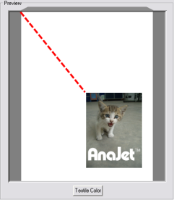

Figure 9c: Left/Top Axis Origin Configuration

- Center: Selecting this means that images will be offset based on the distance from the center of the Print Table to the center of the image file. Some users prefer this setting for positioning of pocket drops, because it allows for the placement of a print based on the image’s center. [Note that center based offsets allow for negative values.]
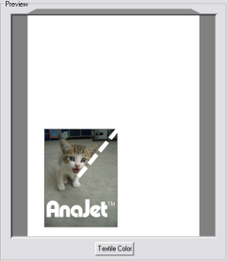

Figure 9d: Center Axis Origin Configuration

- Grid
- Selecting Grid enables a gray grid on the preview screen.

- The Width and Height of the grid are independently adjustable once the grid is enabled.

- Snap to Grid: Enabling Snap to Grid will cause any image to move to the top left corner of the nearest grid square when being dragged with the mouse.

- Landscape Mount: When using a Landscape table size, this option lets you choose which way the top of the shirt will be positioned when the shirt is loaded.

- Pocket Grid: This option provides a visual aid when printing with the pocket print adapter. When this option is enabled, a rectangle will appear in the preview areas representing where the pocket adapter will be.

- Ink Channels: Clicking on the Configuration button will bring up the Ink Channels Configuration Window.

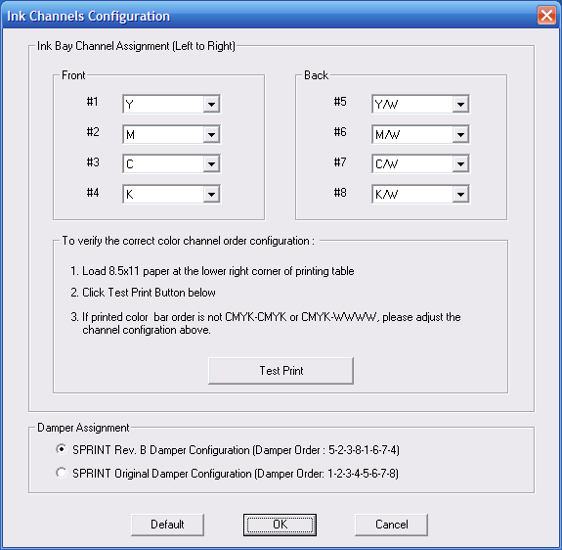

Figure 9e: Ink Channels Configuration

The Ink Channels Configuration allows you to rearrange the ink channel order for the printer. Also here is the Damper Assignment configuration selection.
  - If your SPRINT printer’s serial number is 4569 or higher, or if you have performed the Rev. B upgrade on your machine, leave the setting on the default SPRINT Rev. B Damper Configuration.
  - If your printer’s serial number is 4568 or below and you have not performed the Rev. B upgrade on your machine, be sure to choose the SPRINT Original Damper Configuration setting.

- Save Options

There are two types of saves in EKPrint Studio for SPRINT: Save Project and Save Template.

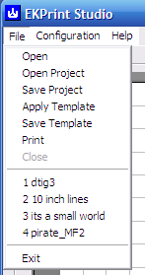

Figure 10a: Save Types

- Save Project will save the graphic along with all of the current EKPrint settings into an .eks file. Notes can be saved as well.
- Save Template will save all of the current EKPrint settings into an .ekt file. The graphic itself will not be saved in the file.

- Calling EKPrint Studio Direct From Graphics Application

EKPrint Studio for SPRINT has the ability to load a graphic from your graphics application program, such as Photoshop and CorelDraw, directly into EKPrint Studio for SPRINT without having to first save the file. From your graphics application program, simply click file > print while your graphic is open in the application. When the print menu opens, choose the EKPrint RIP driver as the printer. This will launch EKPrint Studio for SPRINT with your graphic loaded. This will work for both Raster based applications (such as MS Paint and Adobe Photoshop) as well as Vector based applications (such as Corel Draw and Adobe Illustrator). By default, the EKPrint RIP is set to work with Raster applications. If you are working with a Vector based application program, when printing to the EKPrint RIP driver, make sure to go into the driver’s options and choose Vector under the Print Mode tab (see Figure 11a).

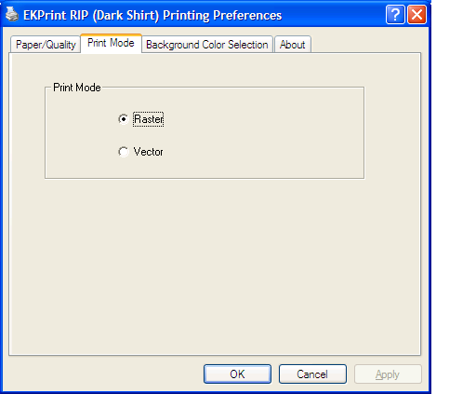

Figure 11a: Selecting Raster or Vector Print Mode

- Basic How To & Recap

How to print a white or light colored garment:
- From EKPrint Studio for SPRINT, click open and browse to the file you wish to print.
- Select the size the image will print.
- Place the image into the correct position. The most common setting is horizontally centered, and one inch from the top of the Print Table area.
- Select the correct Ink Level and Ink Drop Size for your garment. The most common setting for t-shirts is Ink Level: 3 and Ink Drop Size: Medium.
- Select the appropriate Color Mode for your image type. The most common color mode is Vivid.
- Press the onscreen print button to send the job to the SPRINT printer.

Recap: How to print on a Black or Dark garments with white ink:

- From EKPrint Studio for SPRINT, click open and browse to the file you wish to print.
- Select the size the image will print.
- Place the image into the correct position. The most common setting is horizontally centered, and one inch from the top of the Print Table area.
- Select the correct Ink Level and Ink Drop Size for your garment. The most common setting for dark t-shirts is Ink Level: 2 and Ink Drop Size: Light.
- Select the appropriate Color Mode for your image type. The most common color mode is Vivid.
- Find “White Ink Underbase” and check the Enabled check box. This will cause the printer to print white ink as underbase prior to printing CMYK.
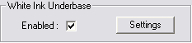
Figure 13a: White Ink Underbase
- If you would like to adjust your white ink controls, click the Settings button. The most common setting is Level: 2 and White Drop Size: Heavy.
- Press the onscreen button to send the job to the SPRINT printer.

AnaJet Limited Warranty Information

AnaJet’s warranty obligation is limited to the terms set forth below. AnaJet Inc. warrants its products to be free from defects in material and workmanship during the warranty period. If a product proves to be defective in material or workmanship during the warranty period, AnaJet will, at its sole option, repair or replace the product with a similar product. Replacement product or parts may include remanufactured or refurbished parts or components. The replacement unit will be covered by the balance of the time remaining on the customer's original limited warranty. AnaJet provides no warranty for the third-party software, including graphics programs and RIP programs, which may be included with the product or installed by the customer.
Warranty Period: (i) AnaJet apparel printers (excluding print heads) have one year limited warranty from the date of delivery. (ii) The print heads have ninety (90) day limited warranty from the date of delivery. (iii) The inks, cleaning fluid, pre-treatment liquid and ink cartridges have six month limited warranty from the date of purchase.
What is Not Covered: (i) Physical damage to the product; (ii) Damage caused by improper installation, improper use, failure to follow instructions included in the manual, misuse, accident, neglect, and use other than the product is designed for; (iii) Damage due to causes external to the product such as improper operating environment (such as operating outside the required temperature and humidity range), improper electric power or power fluctuation, fire, water, etc.; (iv) Damage caused during shipment and transportation; (v) Damage arising out of use of non-AnaJet brand inks, ink cartridges, other consumables and accessories; (vi) Consumables such as ink drip foam, cleaning applicators, waste ink bottles; and print table top which has been subjected to more wear and tear than normal use; (vii) Problems caused by matters other than defects in materials and workmanship; (xiii) Problems arising out of neglect of normal maintenance; (x) The warranty is void if the product has been altered or modified in any way.
Software programs: AnaPrint software/driver, utility and RIP programs are licensed to customer for use with one AnaJet printer. Each printer requires separate license or payment. The programs are protected by copyright, and should not be reproduced or made available to a third party. The software is provided on an ‘as is’ basis, and no warranty is extended for its correctness, completeness or to be free from errors or omissions. AnaJet will provide a replacement CD containing the software if the original CD is defective for a period of three(3) months from the date of delivery.
Non-Transfer of printer warranty: The warranty on printer is not transferable, unless the new owner receives full training for the proper operation and maintenance of the printer from AnaJet (fee required) and the condition of the printer is approved by AnaJet(fee required).
Shipping and RMA: (i) If AnaJet determines any product should be returned to AnaJet for repair or replacement, customer must obtain a Return Material Authorization Number (RMA#) from AnaJet. (ii) Printer must be properly packaged in the original shipping container. (iii) All products being returned must be shipped freight pre-paid with adequate insurance. RMA# must appear on the shipping box. (iv) AnaJet will not accept any return materials unless freight is prepaid, and RMA# is shown on the box prominently. (v) AnaJet is not responsible for losses due to poor packaging and the lack of adequate insurance. (vi) Customer pays for the in-bound freight; AnaJet pays for the out-bound freight ground shipment. Customer can request to ship warranty return items by a faster mode, by paying the increased portion of the shipping cost.

THIS WARRANTY IS EXCLUSIVE AND IN LIEU OF ALL OTHER WARRANTIES, EXPRESS OR IMPLIED. ANAJET DISCLAIMS ANY AND ALL IMPLIED WARRANTIES, INCLUDING, WITHOUT LIMITATION, WARRANTIES OF MERCHANTABILITY AND FITNESS FOR A PARTICULAR PURPOSE. IF ANAJET CANNOT LAWFULLY DISCLAIM IMPLIED WARRANTIES UNDER THIS LIMITED WARRANTY, ALL SUCH WARRANTIES, INCLUDING WARRANTIES OF MERCHANTABILITY AND FITNESS FOR A PARTICULAR PURPOSE ARE LIMITED IN DURATION TO THE DURATION OF THIS WARRANTY. No AnaJet reseller, agent, or employee is authorized to make any modification, extension, or addition to this warranty. ANAJET IS NOT RESPONSIBLE FOR DIRECT, SPECIAL, INCIDENTAL OR CONSEQUENTIAL DAMAGES RESULTING FROM USE OR NON-USE OF ANAJET PRODUCTS, ANY DEFECTS IN THE PRODUCTS, BREACH OF WARRANTY, OR UNDER ANY OTHER LEGAL THEORY, INCLUDING BUT NOT LIMITED TO LOST PROFITS, DOWNTIME, GOODWILL, DAMAGE TO OR REPLACEMENT OF EQUIPMENT AND PROPERTY.

(c) 2014 AnaJet, Inc. All rights reserved. 05012014

